CFS Mattress Fundraiser

Sales App User Guide
Everything you need to take orders, check customers out and run the event.
1  Sales floor  Build the order with the customer | → | 2  Checkout  Take payment and signatures | → | 3  Sales sheet  Print the finished receipt

For sales reps, checkout staff and event administrators
September 2026

Contents
Welcome 4
How a sale moves through the app 4
What you'll need 4
Who can do what 5
Getting started 6
Signing in 6
Changing your PIN 6
Finding your way around 7
Light and dark mode 7
Signing out 7
Taking an order on the sales floor 8
Starting an order 8
Adding items 9
Adding shipping or a service later 11
Changing or removing an item 12
Customer details 12
Sending the order to checkout 13
Using a phone 14
Checking out a customer 15
1. Review the order with the customer 15
2. Take payment 15
3. Acknowledgements (initials and signature) 16
4. Complete the sale 17
Other checkout actions 18
The sales sheet 19
Emailing a receipt 19
Looking up orders 21
Extra options for admins 21
The dashboard 23
Keeping inventory 25
What's on the screen 25
Updating a count 25
What changes the count automatically 26
Seeing the history 27
Notes for the inventory sheet 27
Start and end counts 27
Admin: setting up an event 29
Creating or editing an event 29
Closing out an event 30
Event sales sheets 30
Admin: managing the catalog 33
Adding or editing a product 34
Delivery and services 35
Admin: managing the crew 37
Admin: settings 39
Business details 39
Receipt email 39
Dashboard 41
Owner: permanent deletes 43
Tips and troubleshooting 45
Quick reference 47
Sales rep checklist 47
Checkout checklist 47
Inventory counts 47
Order status at a glance 47

Welcome
The CFS Sales App replaces the paper sales sheet at a mattress fundraiser. Reps build each customer's order on a tablet or phone, checkout collects payment and signatures, and the app prints a sales sheet that looks just like the paper one. The running totals for the day update on their own, so nobody has to add anything up by hand.

How a sale moves through the app
Every order goes through the same simple path:
Stage | Who handles it | What happens
On the floor | Sales rep | The rep adds mattresses, pillows, sheets and so on, picks shipping, and fills in the customer's details. When it's ready the rep taps Complete.
At checkout | Checkout team | The order appears in the checkout queue right away. Checkout records payment, has the customer initial and sign, then taps Complete sale and prints or emails the sales sheet.
Completed | Anyone | The sales sheet can be printed or emailed to the customer, and the sale counts toward the dashboard totals.
Voided | Checkout or admin | A cancelled sale. It stays on file but doesn't count toward any totals.

What you'll need
- A tablet, phone or computer with a web browser and an internet connection.
- The web address for your cart's app (your administrator will give it to you).
- Your username and PIN. Your administrator sets these up, and there's no sign-up page.
Tip: The app is designed for tablets first. Buttons are big enough to tap with a thumb, and on a phone the menu moves to the bottom of the screen.

Who can do what
Every crew member has a role. Your role decides which menu items you see, so don't worry if a screen described in this guide doesn't show up for you.
Role | Best for | Can use
Sales | Reps on the sales floor | Sell, Orders, Dashboard
Checkout | The payment table | Checkout, Orders, Inventory, Dashboard
Sales & Checkout | Crew who work both tables | Sell, Checkout, Orders, Inventory, Dashboard
Admin | Event leads and managers | Everything above, plus Catalog, Events and Crew. Admins can also reopen finished orders and look back at past events.
Owner | Whoever runs the business | Everything an admin can do, plus deleting events, orders, crew accounts and catalog items permanently. Only an owner can make someone else an owner.

Getting started

Signing in
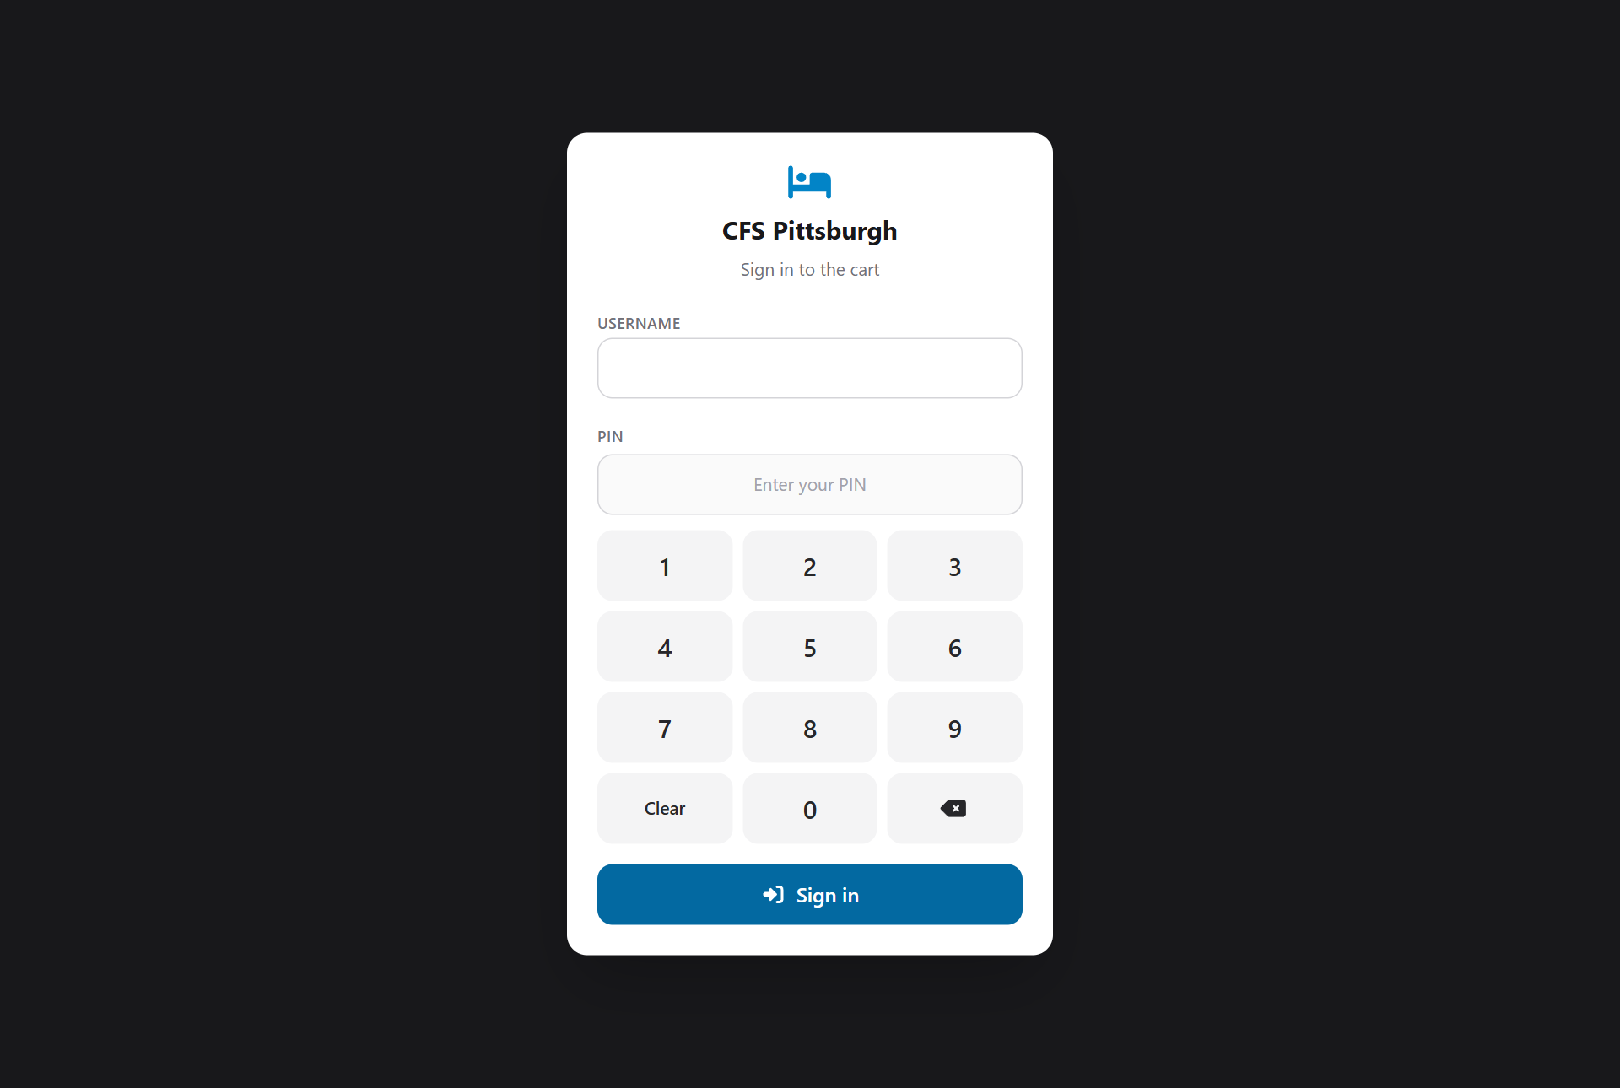
The sign-in screen
1. Open the app's web address in your browser.
2. Type your Username.
3. Tap your PIN on the keypad. Each digit shows as a dot. Clear starts over, and the arrow key removes the last digit.
4. Tap Sign in. The app takes you straight to your main screen: Sell for sales reps and Checkout for the checkout team.
Tip: On a laptop you can type the PIN on the keyboard instead, and press Enter to sign in.

Good to know: Forgot your PIN? An administrator can set a new one for you on the Crew screen.

Changing your PIN
You can change your own PIN at any time, without asking an administrator:
1. Tap your initials in the top-right corner, then tap Change PIN.
2. Enter your Current PIN, then your New PIN twice. A PIN is 4 to 12 digits.
3. Tap Change PIN. Use the new one the next time you sign in.
Tip: Everyone starts with a PIN set by an administrator, so it's a good idea to change yours the first time you sign in.

Finding your way around
The menu bar lists only the screens your role can use:
Menu item | What it's for
Sell | Build new orders on the sales floor.
Checkout | Collect payment and signatures for orders that are ready.
Orders | Look up any order and reprint its sales sheet.
Dashboard | Live totals for the day or the event.
Inventory | Checkout and admins: count the pillows, protectors and other items kept at the cart.
Catalog | Admins: products, prices, sizes and delivery options.
Events | Admins: set up fundraisers, tax rate and card fee.
Crew | Admins: accounts, roles and PINs.

On a tablet or computer the menu runs along the top. On a phone it moves to the bottom so it's always within thumb reach. When there are more screens than fit on the bar (as there are for admins), the last button is More. Tap it to reach the rest.

Light and dark mode
Tap the half-moon button in the top-right corner to switch between light, dark and your device's own setting. Dark mode is easier on the eyes at an evening event.

Signing out
Tap your initials in the top-right corner, then tap Sign out. Please always sign out on a shared tablet at the end of your shift, since orders are recorded under the person who is signed in.

Taking an order on the sales floor
Tap Sell in the menu. The fundraiser's name appears at the top of the screen, followed by a tab for each order you have open.
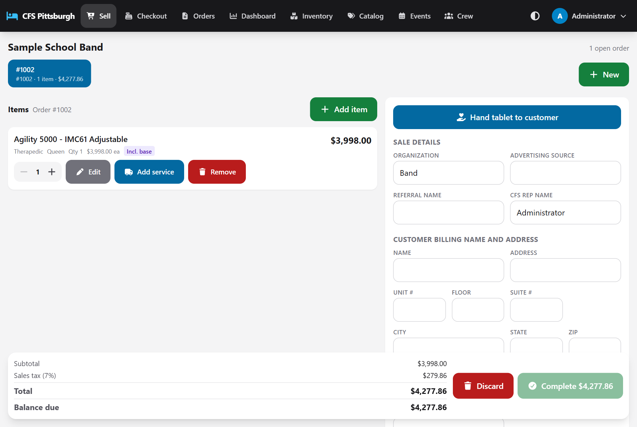
The sales floor: items on the left, customer details on the right, totals along the bottom
Important: If you see No active event, orders can't be taken yet. Ask an administrator to turn on the event under Events.

Starting an order
1. Tap New (top right). A new tab appears with the next order number, for example #1002.
2. Add the customer's items and details as described below. Everything saves as you go. There is no Save button.

Working with several customers at once
Each open order gets its own tab showing the order number, how many items it has and its total. Tap a tab to switch customers. You can leave one family deciding between mattresses while you help the next, and nothing gets mixed up.

Adding items
1. Tap Add item.
2. Pick a category along the top (Mattresses, Bases, Pillows, Sheets, Protectors, Frames, Bean Bags) or stay on All.
3. Find the product. Scroll the list, or type part of the model or brand name into Search.
4. Tap the product to open its details.
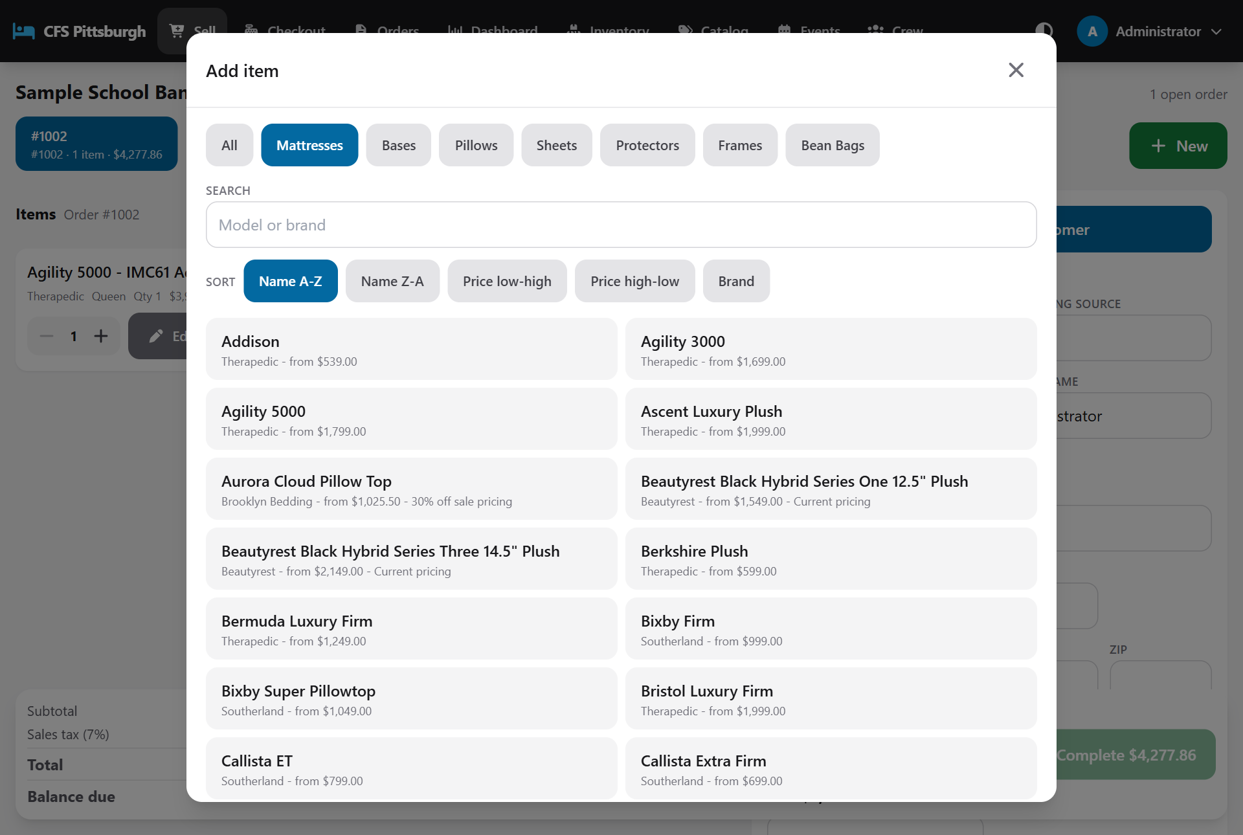
Choosing a product. Each tile shows the brand and starting price.

Sorting the list
The Sort buttons change the order of the list. It starts on Name A-Z. You can also sort Name Z-A, Price low-high, Price high-low or by Brand. Products stay grouped by category. Items without a set price (marked Inquire) always sort to the end when you sort by price.

Choosing size, shipping and quantity
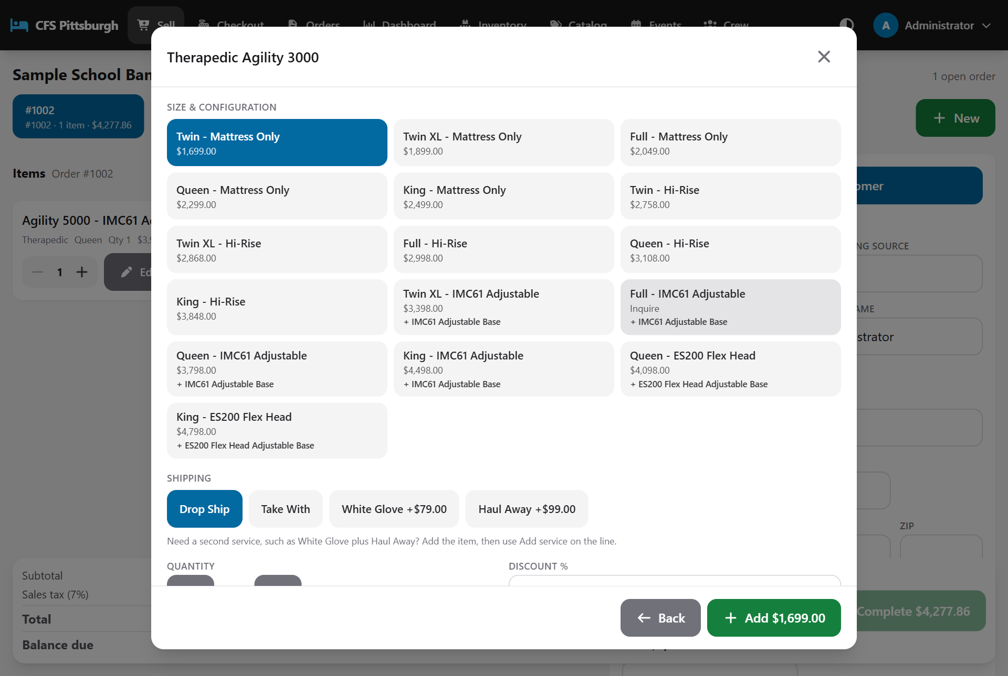
Choosing the size and configuration, shipping, quantity and discount
1. Tap the Size & configuration the customer wants, for example Queen - Mattress Only. The price is shown on each option.
2. Under Shipping, pick how it gets to the customer: for example Drop Ship, Take With, White Glove or Haul Away. Only the options offered for that product appear.
3. Set the Quantity with the + and - buttons.
4. Enter a Discount % if one applies (optional).
5. Add a Note if there's something to record about this item, for example "Floor model - small scuff on the corner" (optional). It prints on the sales sheet under the item.
6. Tap the green Add button. It shows the line total so the customer knows the price before it goes on the order.

Items we have on hand
Some accessories, such as pillows and mattress protectors, are kept at the cart so customers can take them home today. For these items the list shows how many are in stock, and each size shows its own count.
- Take With is only available while the size is in stock. If the cart doesn't have enough, the Take With button is greyed out and shows Out of stock or Only 2 in stock.
- An out-of-stock size can still be sold. Just choose a shipping method such as Drop Ship.
- Items that aren't counted, like mattresses, never show a stock number and are never blocked.
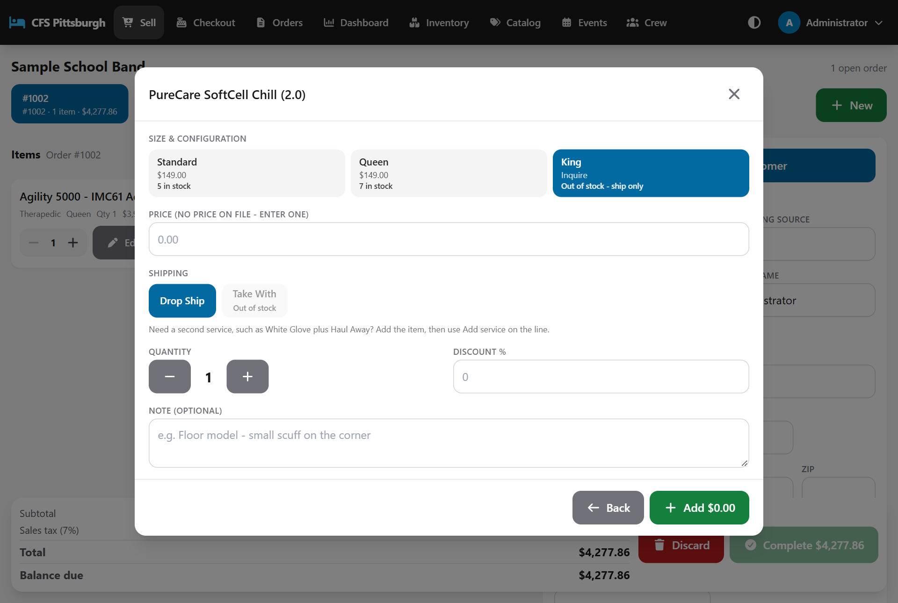
The King size is out of stock, so Take With is greyed out and the pillow will ship
Good to know: Some sizes show Inquire instead of a price. When you pick one, a Price box appears so you can type in the price you and the customer agreed on.

Tip: Selling something that isn't in the catalog? Tap Something not in the catalog at the bottom of the list, then enter a description, brand, size, price and quantity.

Bundles and included items
Some products come with other items included, such as a mattress set that includes an adjustable base. When you add a bundle, the included items appear on their own lines marked Included and at no extra charge. That way the delivery team and the sales sheet show everything the customer is getting.

Adding shipping or a service later
To add another service to an item that's already on the order (for example White Glove setup, or Haul Away for the old mattress), tap Add service under that item, choose the service and tap Add service.
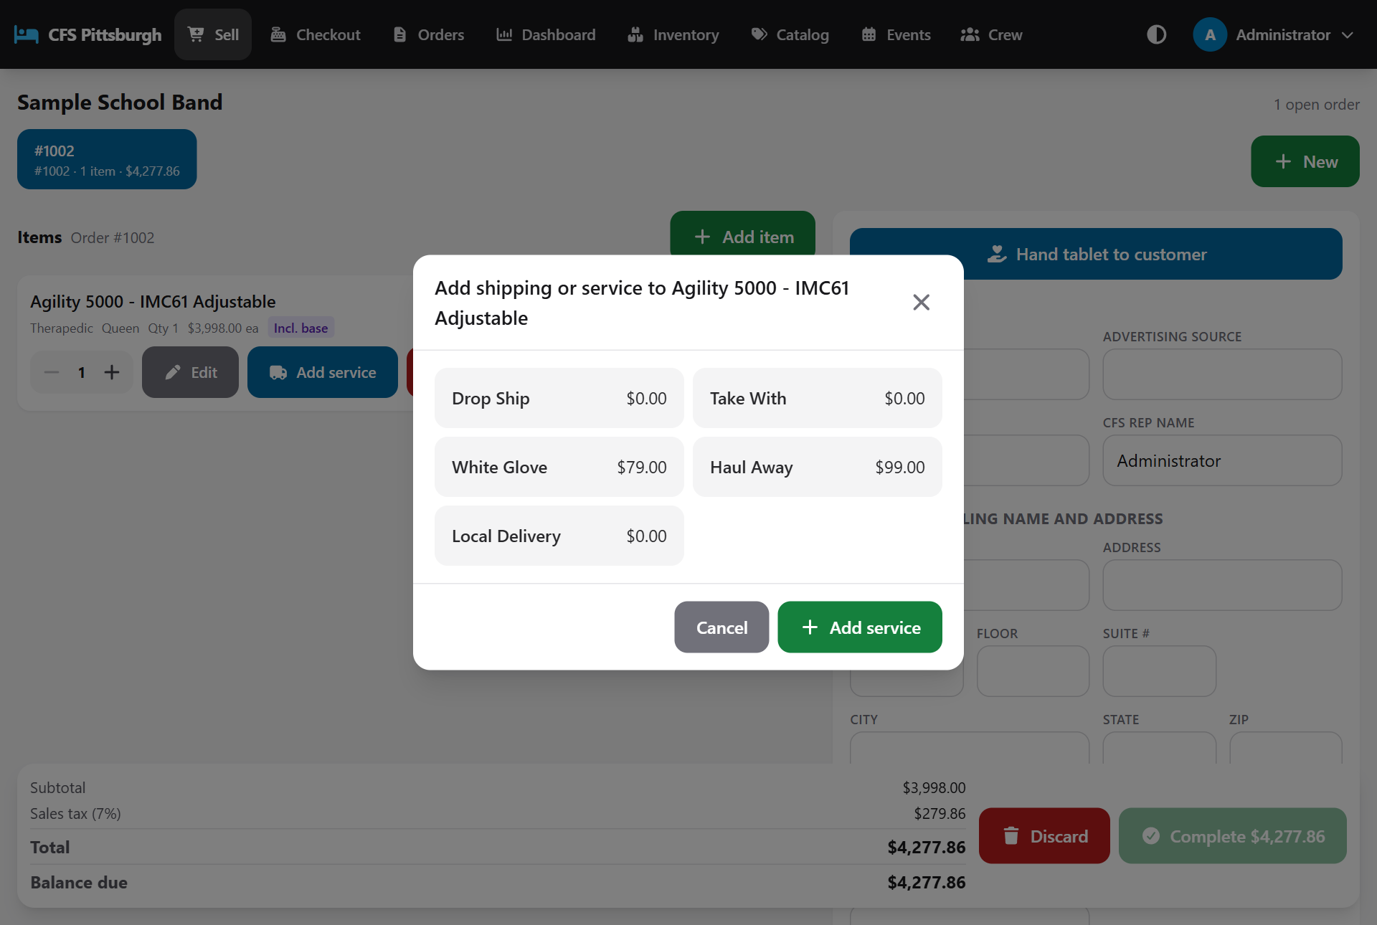
Adding a service to an item already on the order

Changing or removing an item
- Edit lets you change the description, brand, size, unit price, discount and quantity. It also lets you mark the item Take with (the customer carries it out today) or Taxable. For counted items, the Take with box shows how many are in stock and can't be ticked when there aren't enough.
- - and + next to an item change its quantity straight away, without opening Edit.
- Notes: add or change an item's note with Edit. The note shows under the item on screen, and on the sales sheet it prints directly under the item, above its shipping row.
- Remove takes the item off the order. The app asks you to confirm first.
Small labels on each item help you check the order at a glance: Take with, Included (part of a bundle), a discount such as -10%, and Not on sales sheet for a free service row that won't print.

Customer details
The right side of the screen (or the Customer tab on a phone) holds the same fields as the paper sales sheet:
- Sale details: Organization, Advertising source, Referral name and CFS rep name.
- Customer billing name and address: name, street address, unit, floor, suite, city, state, zip, cell, alternate phone and email.
- Delivery address: leave Same as billing ticked, or untick it to enter a different address.
- Comments: anything the delivery crew or checkout table should know.
Details tidy themselves up when you move to the next box: a phone number becomes (724) 555-0100, the state becomes capitals, and the email is lower-cased.

Letting the customer type it in
Customers are often quicker (and more accurate) typing their own address. Tap Hand tablet to customer. The customer sees a simple, large-print form titled Where should we deliver? with only the fields they need, including a choice of delivering To the address above or Somewhere else. When they tap Done, the details drop into the order and they hand the tablet back.
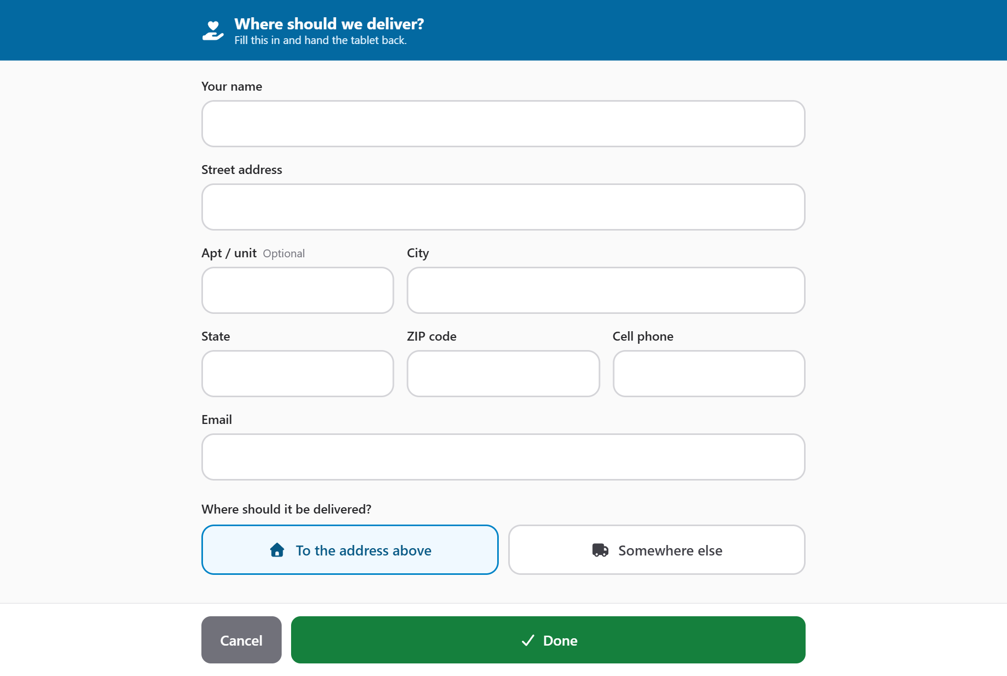
The customer-friendly address form

Sending the order to checkout
The bar along the bottom always shows the subtotal, sales tax, total and balance due. When the order is ready:
1. Check the items and make sure the customer's name is filled in.
2. Tap the green Complete button (it shows the order total).
3. A message confirms the order is with checkout. Walk the customer over to the checkout table.
Good to know: The Complete button stays grey until the order has at least one item and a customer name.

Changed their mind? Discard deletes an order that hasn't been sent to checkout yet. The app asks you to confirm, and this can't be undone.

Using a phone
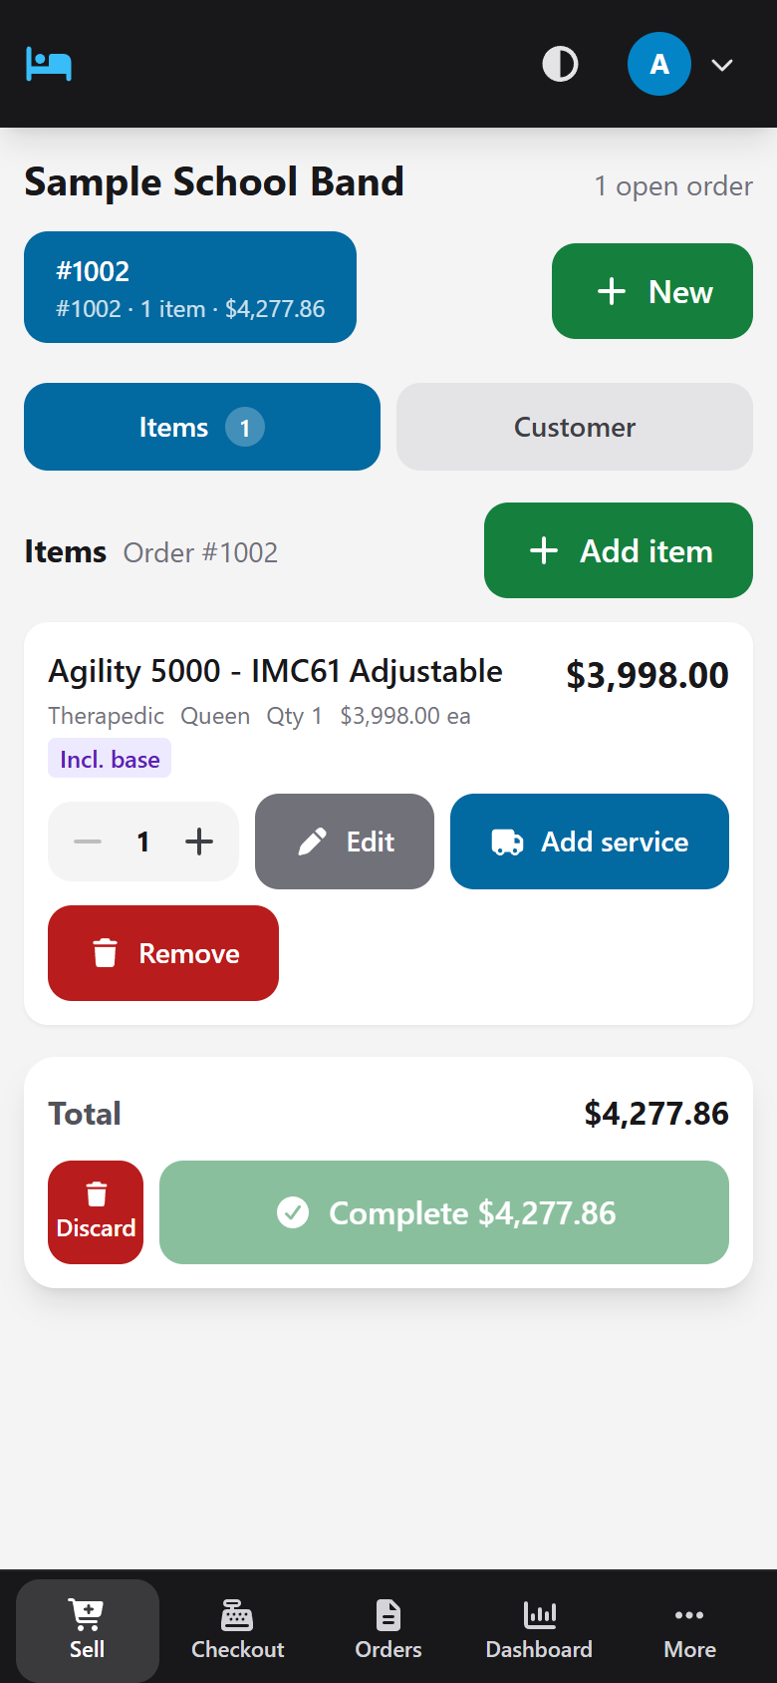
The sales floor on a phone
On a phone, the screen shows Items and Customer as two tabs you can switch between, and the menu moves to the bottom. Everything else works the same way.

Checking out a customer
Tap Checkout in the menu. Orders appear in the Waiting to pay queue the moment a rep completes them, along with the customer's name, the rep, the item count, how long ago the order was sent over and the total. Tap an order to open it.
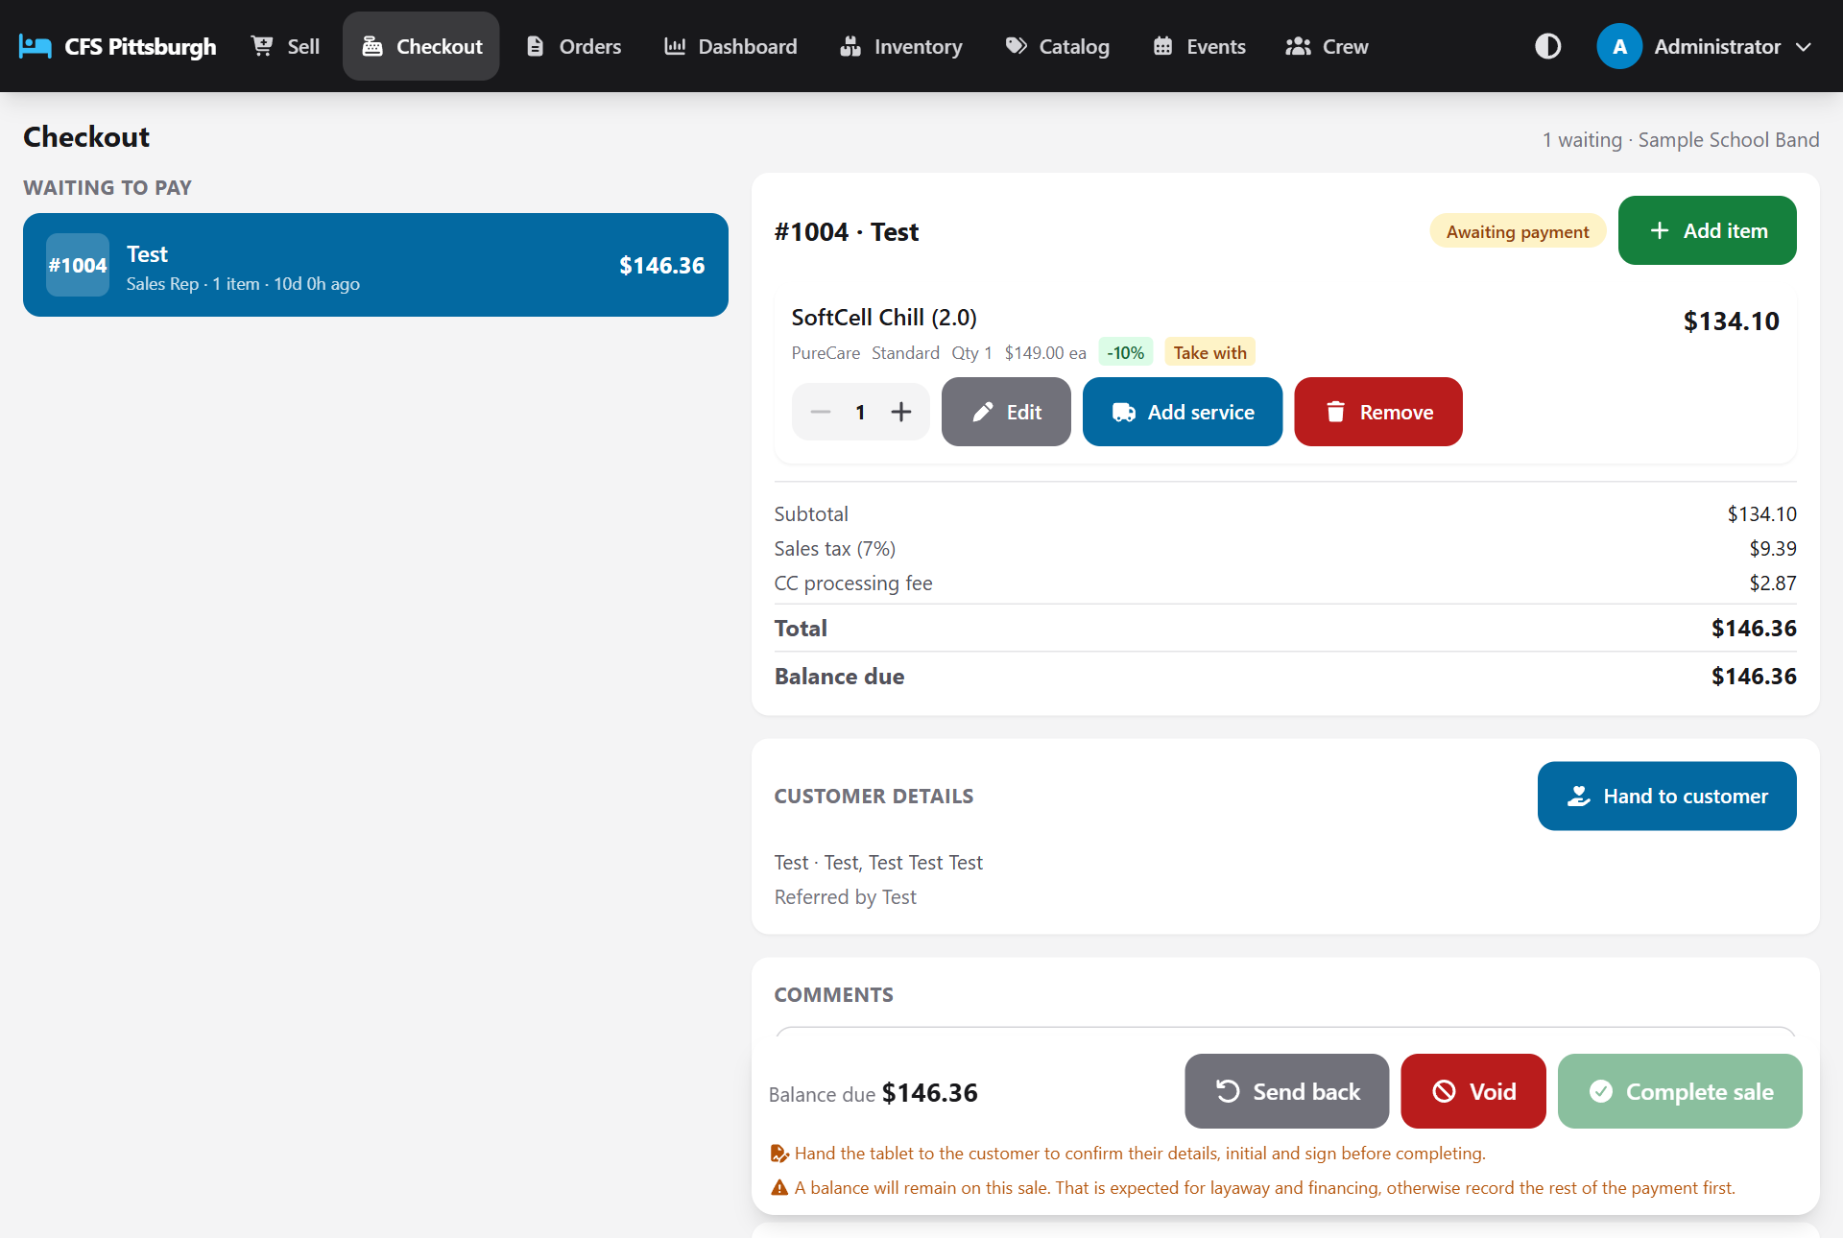
The checkout screen: the queue on the left, the selected order on the right

1. Review the order with the customer
Go over the items and totals with the customer. Checkout can make changes too: Add item, Edit, Add service and Remove work exactly as they do on the sales floor.
Under Customer details, check the name and address. If anything is missing, tap Hand to customer so the customer can fill it in.
Use Comments to add delivery notes, then tap Save comment. Comments print in the Comments box on the sales sheet.

2. Take payment
1. Choose how the customer is paying: Cash (selected to start), Check, Credit/Debit Card, Financing or Layaway.
2. Enter the Amount, or tap Fill to use the full balance due.
3. For a check, enter the Check #.
4. Tap Record payment. The payment is listed below, and the balance due goes down.
Important: When you choose Credit/Debit Card, the card processing fee is added to the total straight away, so the customer sees the real amount before paying. Switch back to another method and the fee comes off.

The fee only applies to the part of the sale paid by card. For example, on a $2,000 order where the customer pays $1,000 in cash and the rest by card, the fee is charged on the $1,000 that goes on the card, not on the whole $2,000.
- Split payments are fine. Record one payment, then choose another method for the rest.
- Recorded a payment by mistake? Tap the trash icon next to it to remove it.
- With Layaway or Financing, it's normal for a balance to remain. The screen reminds you when a balance is left.

3. Acknowledgements (initials and signature)
Tap Hand to customer in the Acknowledgements section and pass the tablet over. The customer is walked through a few short screens:
1. Check your details: their name, address, phone, email, where the order is being delivered, and how each item arrives (for example Drop Ship or Take With). If everything is right, they initial it and tap My details are correct. If something is wrong, they tap Cancel and hand the tablet back so you can fix it.
2. Warranty and mattress protectors, How your bed arrives and All sales are final: they initial each one and tap I understand.
3. Sign to finish: they print their name, sign with a finger in the signature box, and tap Done.
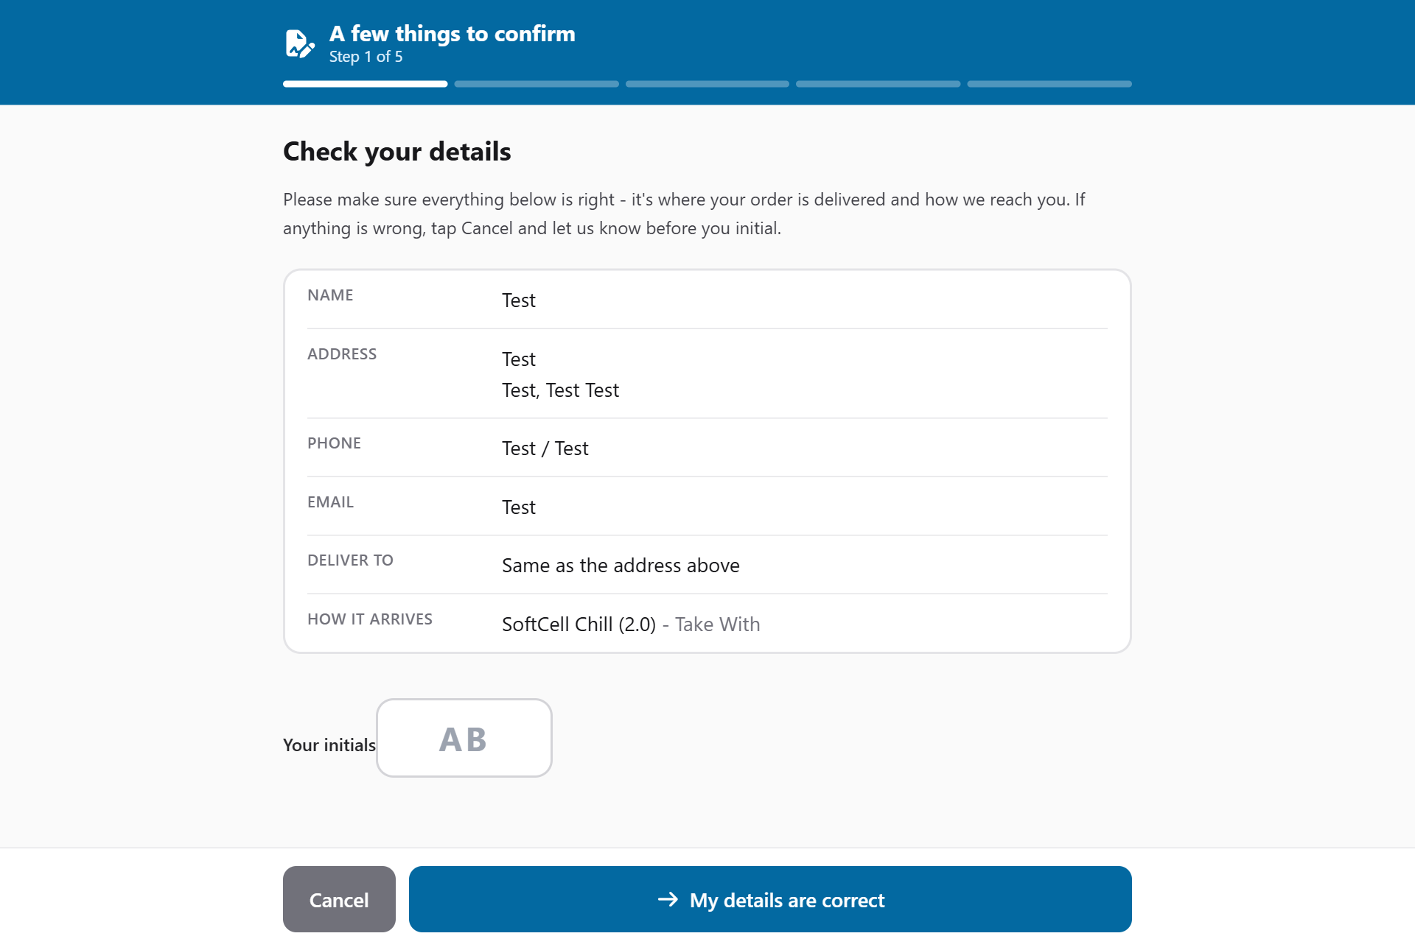
The customer checks their details first, then initials each point and signs
Green check marks show once the details, initials and signature are in. To collect them again, tap Redo.
Important: Complete sale stays greyed out until the customer has confirmed their details, initialled every point and signed. If anyone changes the customer's name, address, phone, email or delivery address afterwards, the customer has to confirm their details again.

4. Complete the sale
Tap Complete sale. The order is marked complete, moves into the day's totals, and its sales sheet opens. From there:
- Tap Print to print the customer's copy (or choose Save as PDF as the printer).
- Tap Email to send the customer a copy by email instead of, or as well as, a printed one (see *Emailing a receipt*).
When you're done, tap Back to checkout to return to the queue.
Good to know: An order needs at least one item, one recorded payment, and the customer's details confirmation, initials and signature before it can be completed.

Completing an order also takes any counted Take With items off the inventory, so the counts stay right without anyone having to update them by hand.
Important: If another customer took the last one while this order was waiting, the app says the item is out of stock and won't complete the order yet. Change that item to ship instead: remove its Take With service row, tap Add service, choose a shipping method such as Drop Ship, then tap Complete sale again.

Other checkout actions
Button | When to use it
Send back | The customer wants to change what they're buying. The order goes back to the sales floor as a draft for the rep who wrote it.
Void | The sale is cancelled. It stays on file for the records but comes off all totals. You'll be asked to confirm.

The sales sheet
The printed sales sheet copies the layout of the paper form: the customer service number, sale details, billing and delivery addresses, every item with its size, shipping and Take With mark, comments, payment options, totals, the warranty and delivery terms, and the customer's initials and signature.
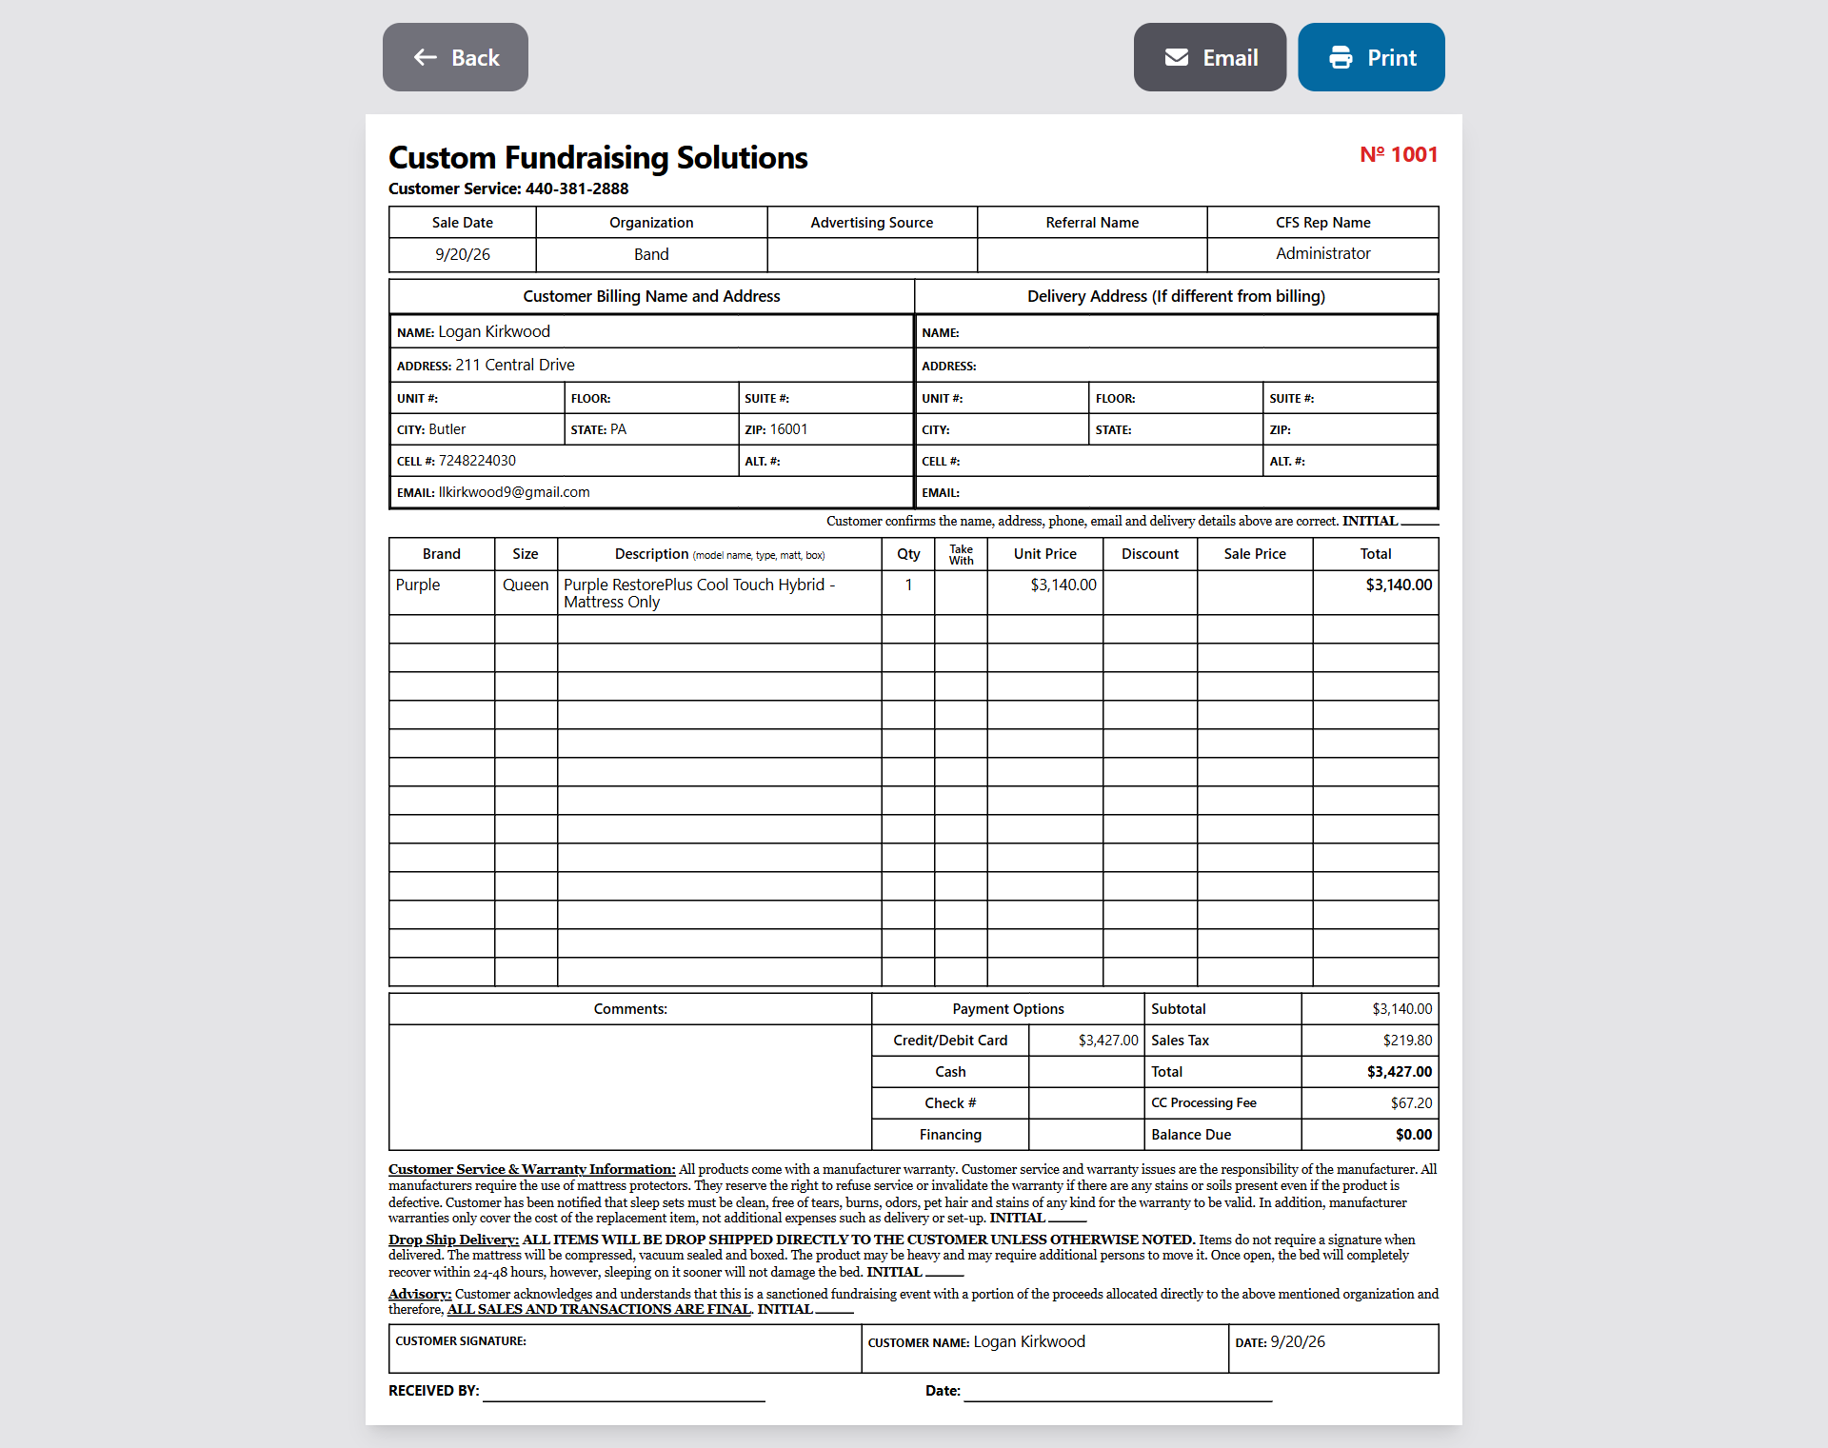
A completed sales sheet
- Tap Print to print it, or choose Save as PDF as the printer to keep a digital copy. Each sales sheet always fits on one page, even for a long order.
- An order that isn't finished yet prints with a clear NOT COMPLETED stamp, so a draft can't be mistaken for a paid sale.
- The CFS Rep Name box shows the sales rep. If a different person checked the customer out, their name is shown there too, marked Checkout.
- Under the addresses, the customer's initials confirm their details are correct.
- Received by and Date at the bottom are left blank to fill in by hand.
- The back button always returns you to the screen you came from.

Emailing a receipt
A customer who would rather have their receipt by email (or wants both) can get one from any completed sales sheet.
1. Open the sales sheet: it opens by itself when checkout completes a sale, or tap Sales sheet on the Orders screen.
2. Tap Email. The customer's email address from the order is already filled in.
3. Check the address with the customer, change it if needed, and tap Send.
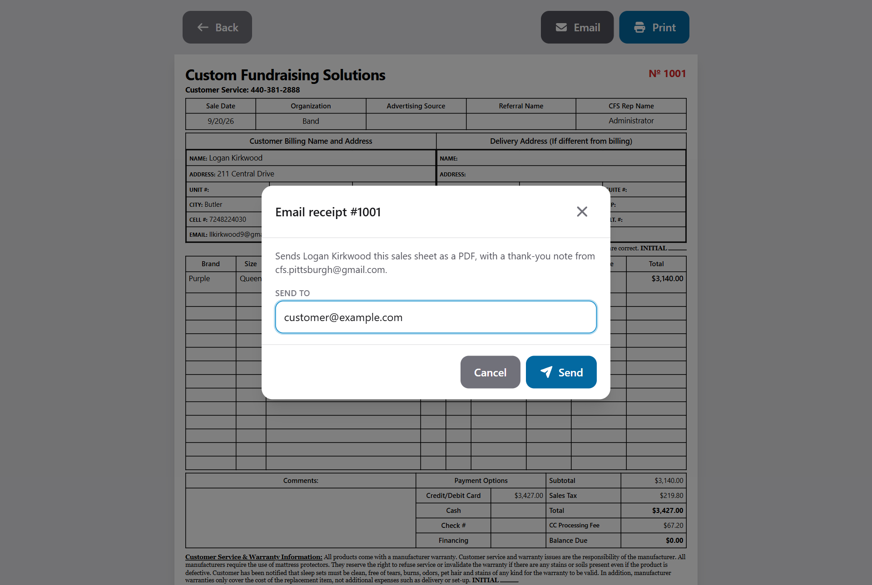
Emailing the customer their receipt
The app turns the sales sheet into a PDF, exactly as it would print, and emails it to the customer with a friendly note. The note thanks them for supporting the organization, explains what happens next (what went home today, what's being shipped and where, how a boxed mattress expands, and keeping a protector on for the warranty), mentions any balance still owed, and gives the customer service number. An administrator can change that wording - see *Admin: settings*.
Making the PDF takes a few seconds. Keep the screen open until the app says the email was sent.
Good to know: The Email button only shows on completed sales. If it says email isn't set up yet, the app hasn't been connected to an email account. Print the receipt instead and let an administrator know.

Looking up orders
Tap Orders to see every order for the current fundraiser. Anyone can use this screen to find an order and reprint its sales sheet.
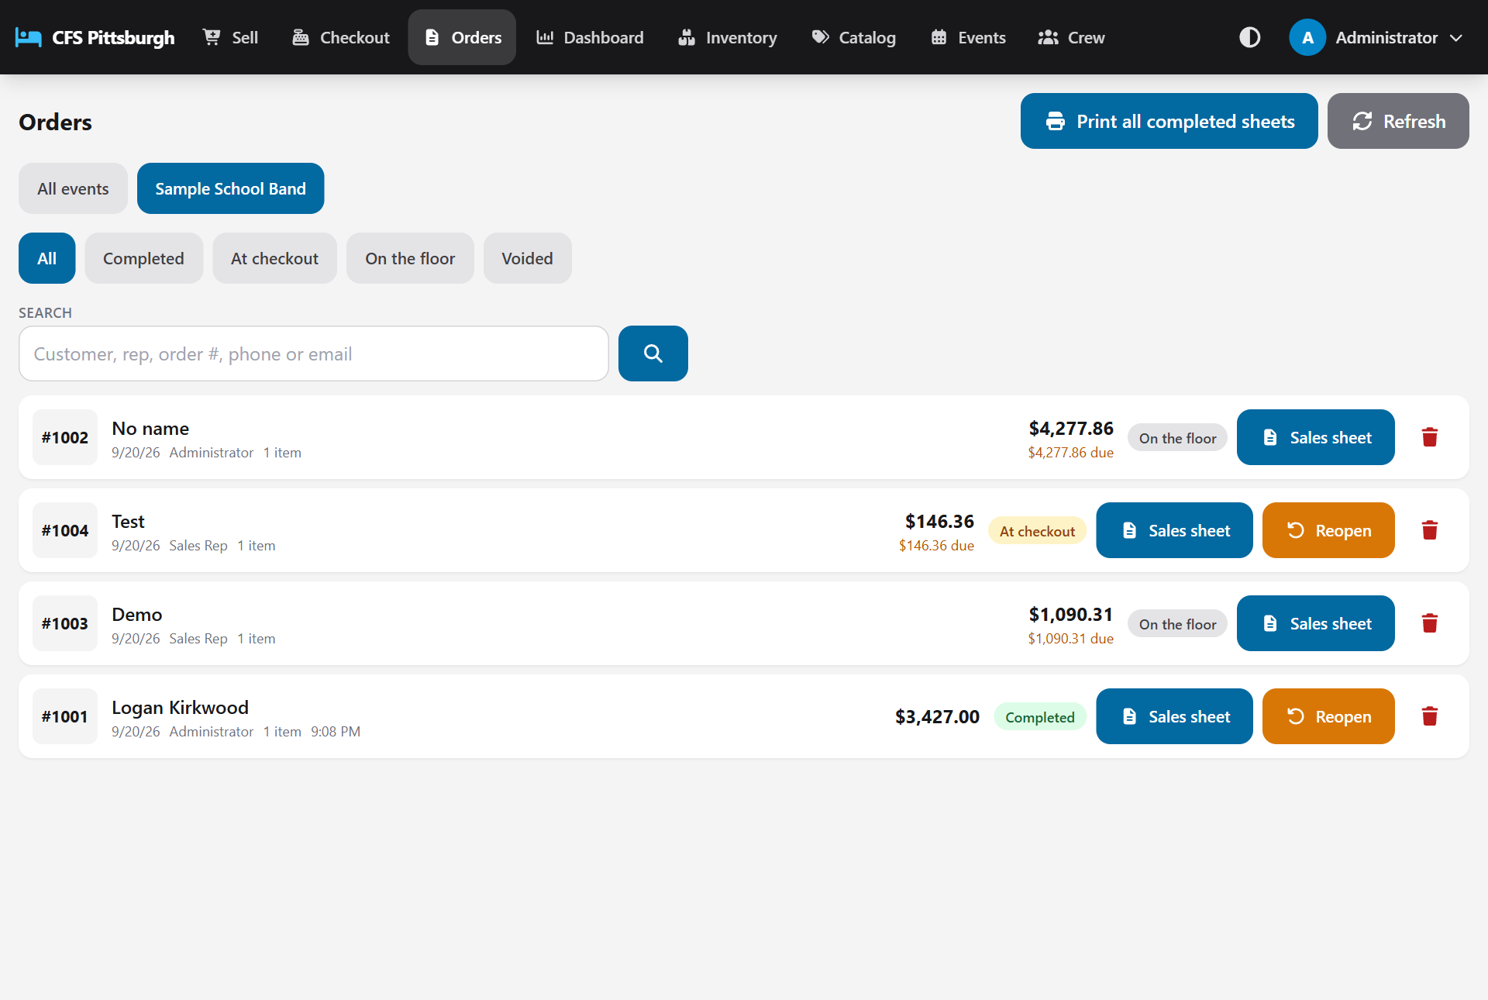
The Orders screen
- Filter by status: All, Completed, At checkout, On the floor or Voided.
- Search by customer name, rep name, order number, phone number or email, then tap the magnifier or press Enter. A phone number matches however it was typed, so 5550100 finds (724) 555-0100.
- Tap Sales sheet on any order to view, print or email it.
- Tap Refresh to pull in the latest orders.

Extra options for admins
- Past events: tap All events or a fundraiser's name to see orders from earlier events.
- Print all completed sheets: opens every completed sales sheet for the event in one print job (see *Event sales sheets*).
- Reopen a finished or in-progress order. Choose Send to checkout to fix a payment, the initials or the signature, or choose Send to the sales floor to change what was sold.
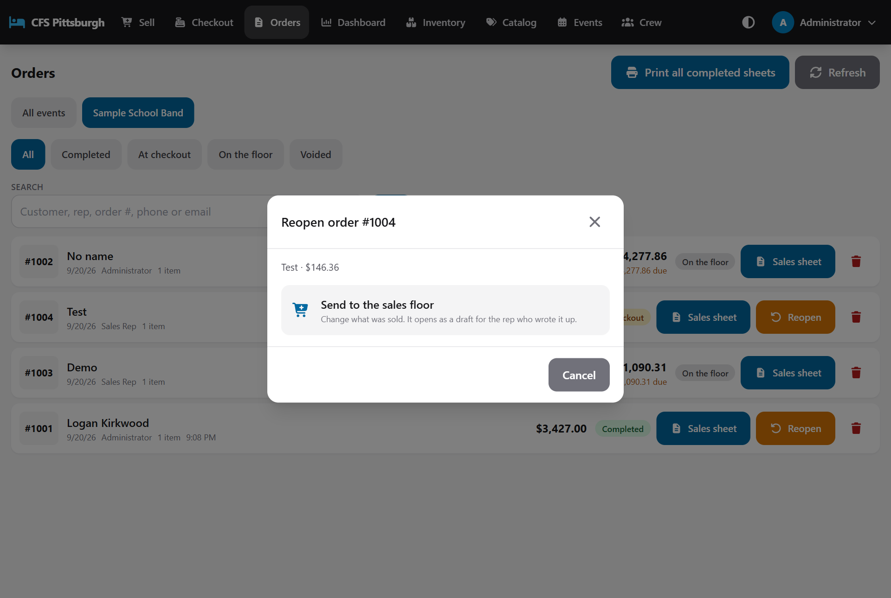
Reopening an order
An Owner also sees a trash icon on each order, which deletes it permanently. See *Owner: permanent deletes*.
Important: A reopened sale drops out of the event's totals and printed sheets until it is completed again. Payments already recorded stay on it. Any counted Take With items go back into the inventory, and come off again when the sale is completed.

The dashboard
Tap Dashboard for live numbers. Choose Today for everything sold today, or a fundraiser's name to see that whole event. Tap Refresh for the latest figures.
On both the Dashboard and the Orders screen, the event buttons run from newest on the left to oldest on the right, with the active event always first. Past events carry a small PAST tag. Events that haven't happened yet aren't listed, since they have no sales.
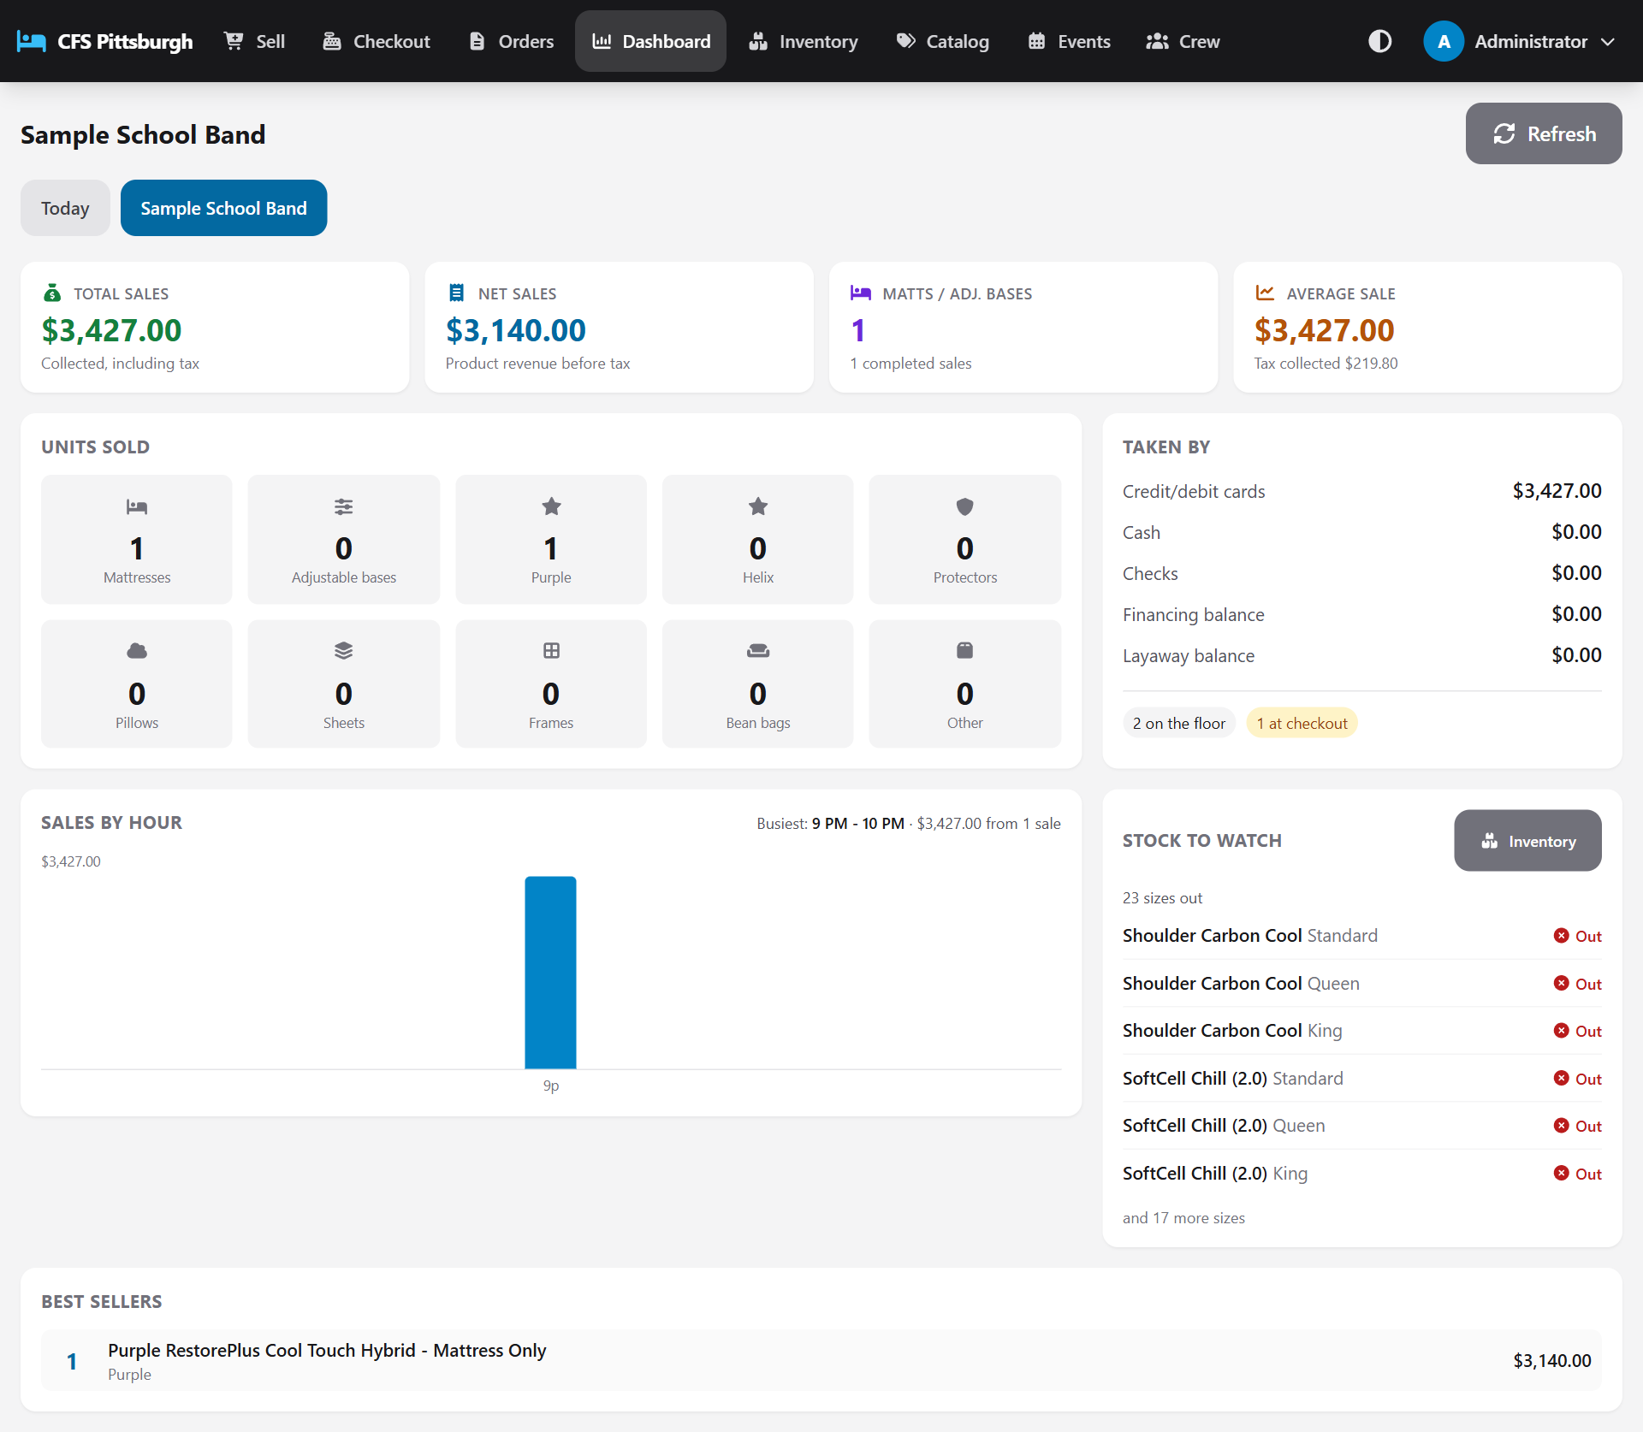
The dashboard
Tile | What it shows
Total sales | Everything collected, including tax.
Net sales | Product revenue before tax.
Matts / adj. bases | Mattresses and adjustable bases sold, plus the number of completed sales.
Average sale | The average completed sale, with the total tax collected.
Units sold | A count for each category: mattresses, adjustable bases, pillows, protectors, sheets, frames and more.
Taken by | Money by payment type (cards, cash, checks), plus financing and layaway balances and orders still on the floor or at checkout.
Best sellers | The top products by sales. Items included free in a bundle aren't counted.

Tip: The Net sales tile earns a gold star when net sales pass $30,000, and another for every $10,000 after that: two stars at $40,000, three at $50,000, and so on. Hover over the stars to see the next milestone. An administrator can change both amounts under Settings.

Below the tiles:
- Sales by hour shows what came in each hour, so you can see the busy stretches at a glance. Hover over or tap a bar for its exact total and number of sales. The busiest hour is named at the top. For an event that ran over several days, the bars show each day instead.
- Stock to watch lists the counted accessories that are out of stock or down to their last couple, so the floor knows what can't go home today and checkout knows what to restock.

Keeping inventory
The Inventory screen keeps count of the accessories the cart carries, such as pillows and mattress protectors, so reps know what customers can take home today. It's available to Checkout, Sales & Checkout and Admin users. Sales reps don't see this screen, but they still see the stock counts when adding items.
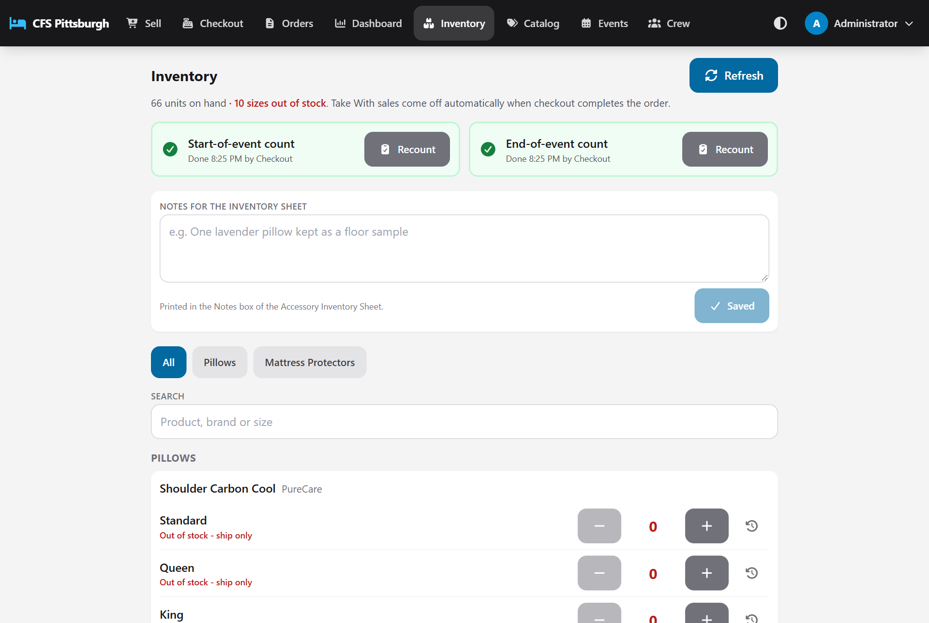
The Inventory screen

What's on the screen
- Each counted product is listed under its category, with one row per size.
- The big number is how many are on hand. It turns red and shows Out of stock - ship only at zero, and shows Running low at 2 or fewer (an administrator can change that level under Settings).
- The line at the top shows the total units on hand and how many sizes are out of stock.
- Use the category buttons or Search to find an item quickly, and Refresh to pick up changes made on another tablet.

Updating a count
There are two ways to change a count:
- Tap + or - to add or remove one. This is handy when a single pillow turns up or is set aside as a floor sample.
- Tap the number itself to type in a new count. Use this when a delivery arrives or at the end-of-event tally. You can add a short Note, such as "Delivery received", then tap Save count.
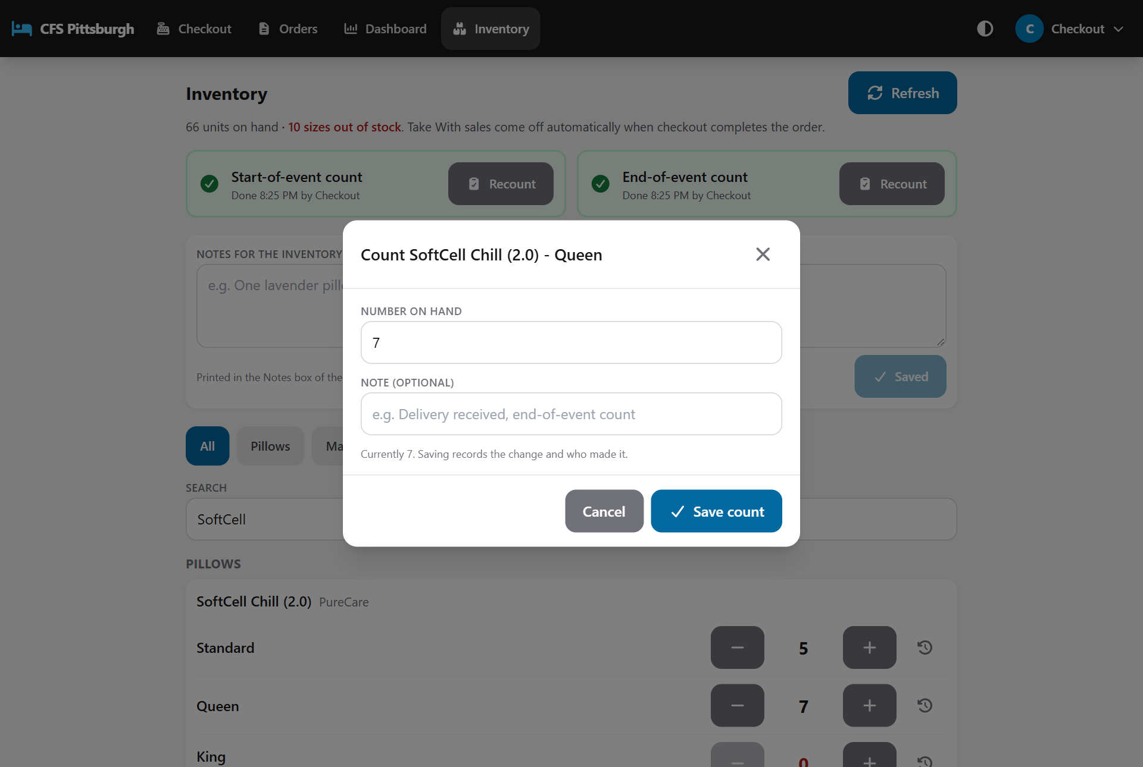
Typing in a new count

What changes the count automatically
When this happens | The count
Checkout completes an order with a counted Take With item | Goes down by the quantity sold.
An admin reopens that completed order, or it's voided | Goes back up, so the stock is available again.
The reopened order is completed again | Goes down again.
An item ships instead (Drop Ship, White Glove and so on) | Doesn't change, because the item isn't leaving the cart.

Good to know: The count only changes when checkout completes the order, not when a rep adds the item. Until then, two open orders could both plan to take the last one. Whoever completes first gets it, and the other order is asked to ship instead.

Seeing the history
Tap the clock icon next to a size to see every change to its count: who made it, when, why (a count change, a Take With sale or a return to stock) and how many were left afterwards.

Notes for the inventory sheet
Below the count boxes is a Notes for the inventory sheet box. Use it for anything the counts don't explain on their own, such as a pillow kept as a floor sample or a damaged box sent back. Type the note and tap Save notes. The notes print in the Notes box of the event's Accessory Inventory Sheet, with ruled lines left underneath for anything added by hand. Admins can also edit them on the event's Sales sheets page, just above the inventory sheet.
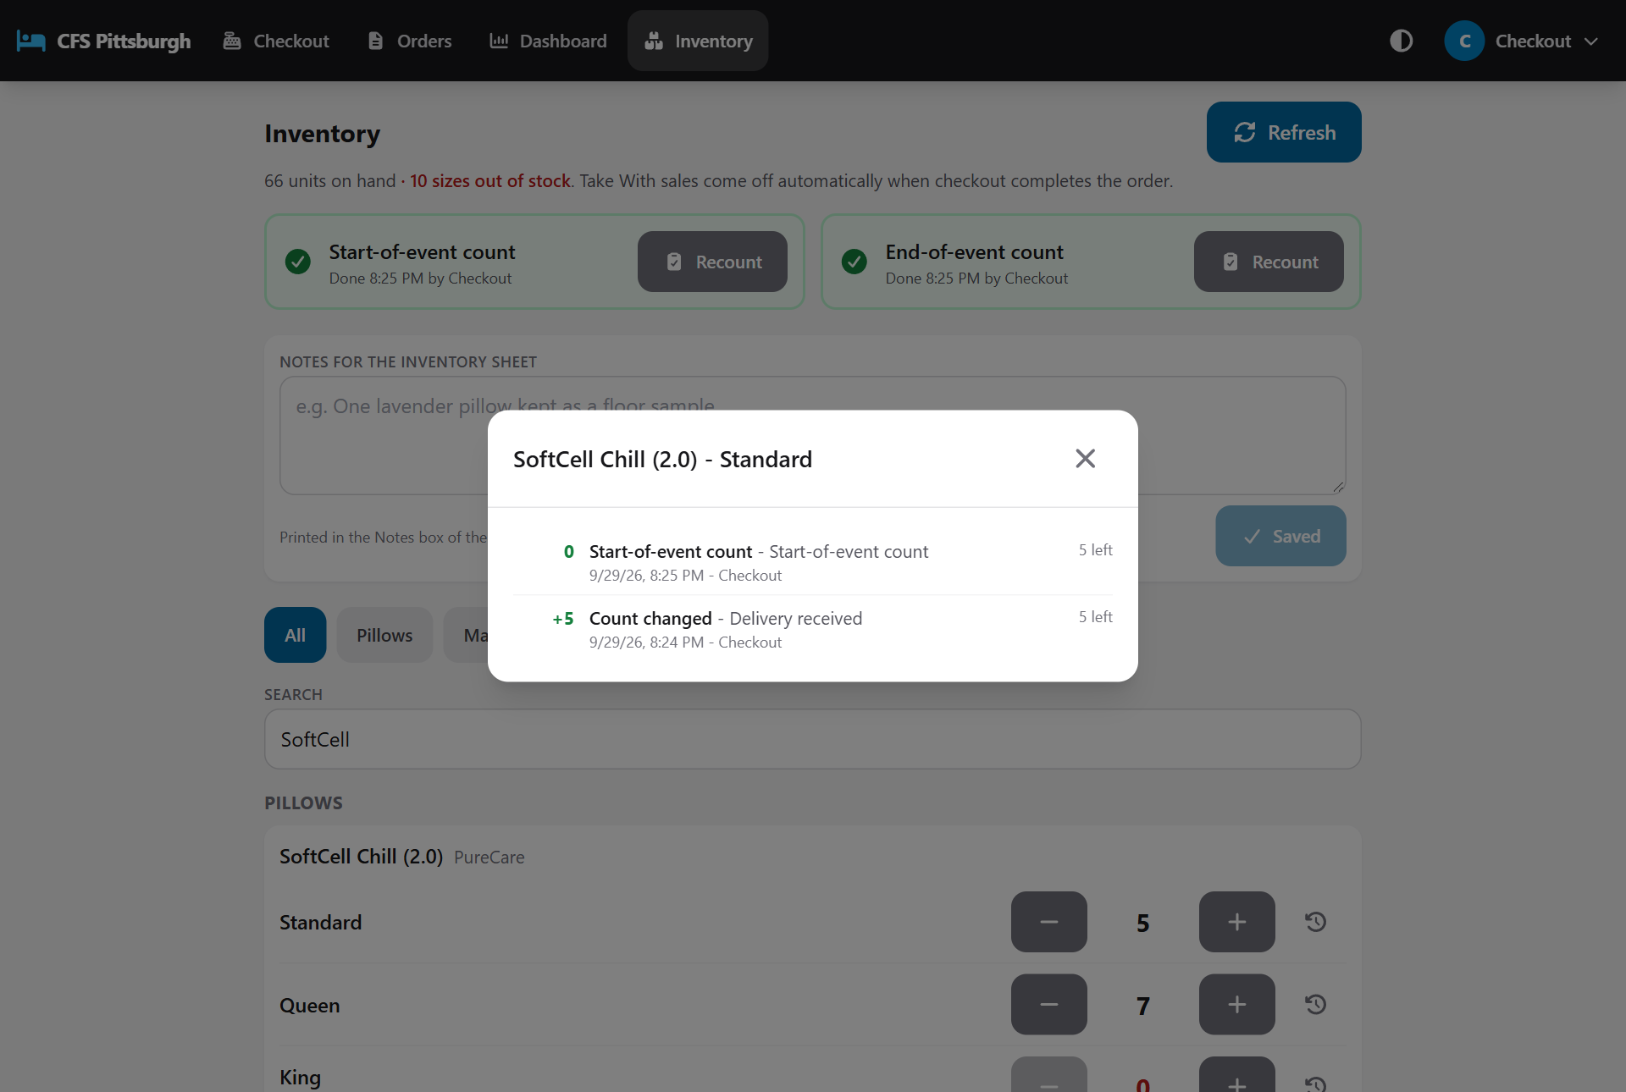
The history of one size

Start and end counts
Each event has two shelf counts, shown in two boxes at the top of the Inventory screen. Each box says whether that count has been done, when, and by whom.
Count | When | Why
Start-of-event count | Before the doors open | Sets what the event starts with, including anything delivered that day. The box shows Not done yet in amber until it's done.
End-of-event count | After the event closes | Checks what's really left against what the app expected.

1. On the Inventory screen, tap Count now in the box for the count you're taking.
2. Work down the list. For each size, type in how many are on the shelf. If it's the same as the Expected number, just tap Matches.
3. If most of the shelf agrees with the app, tap Fill the rest as matching to fill every size you haven't typed yet, then correct just the few that differ.
4. Sizes that differ from what the app expected are marked, for example -1 or +2. Leave a size blank if you're not counting it.
5. Add an optional Note, such as who counted, then tap Save count and confirm.
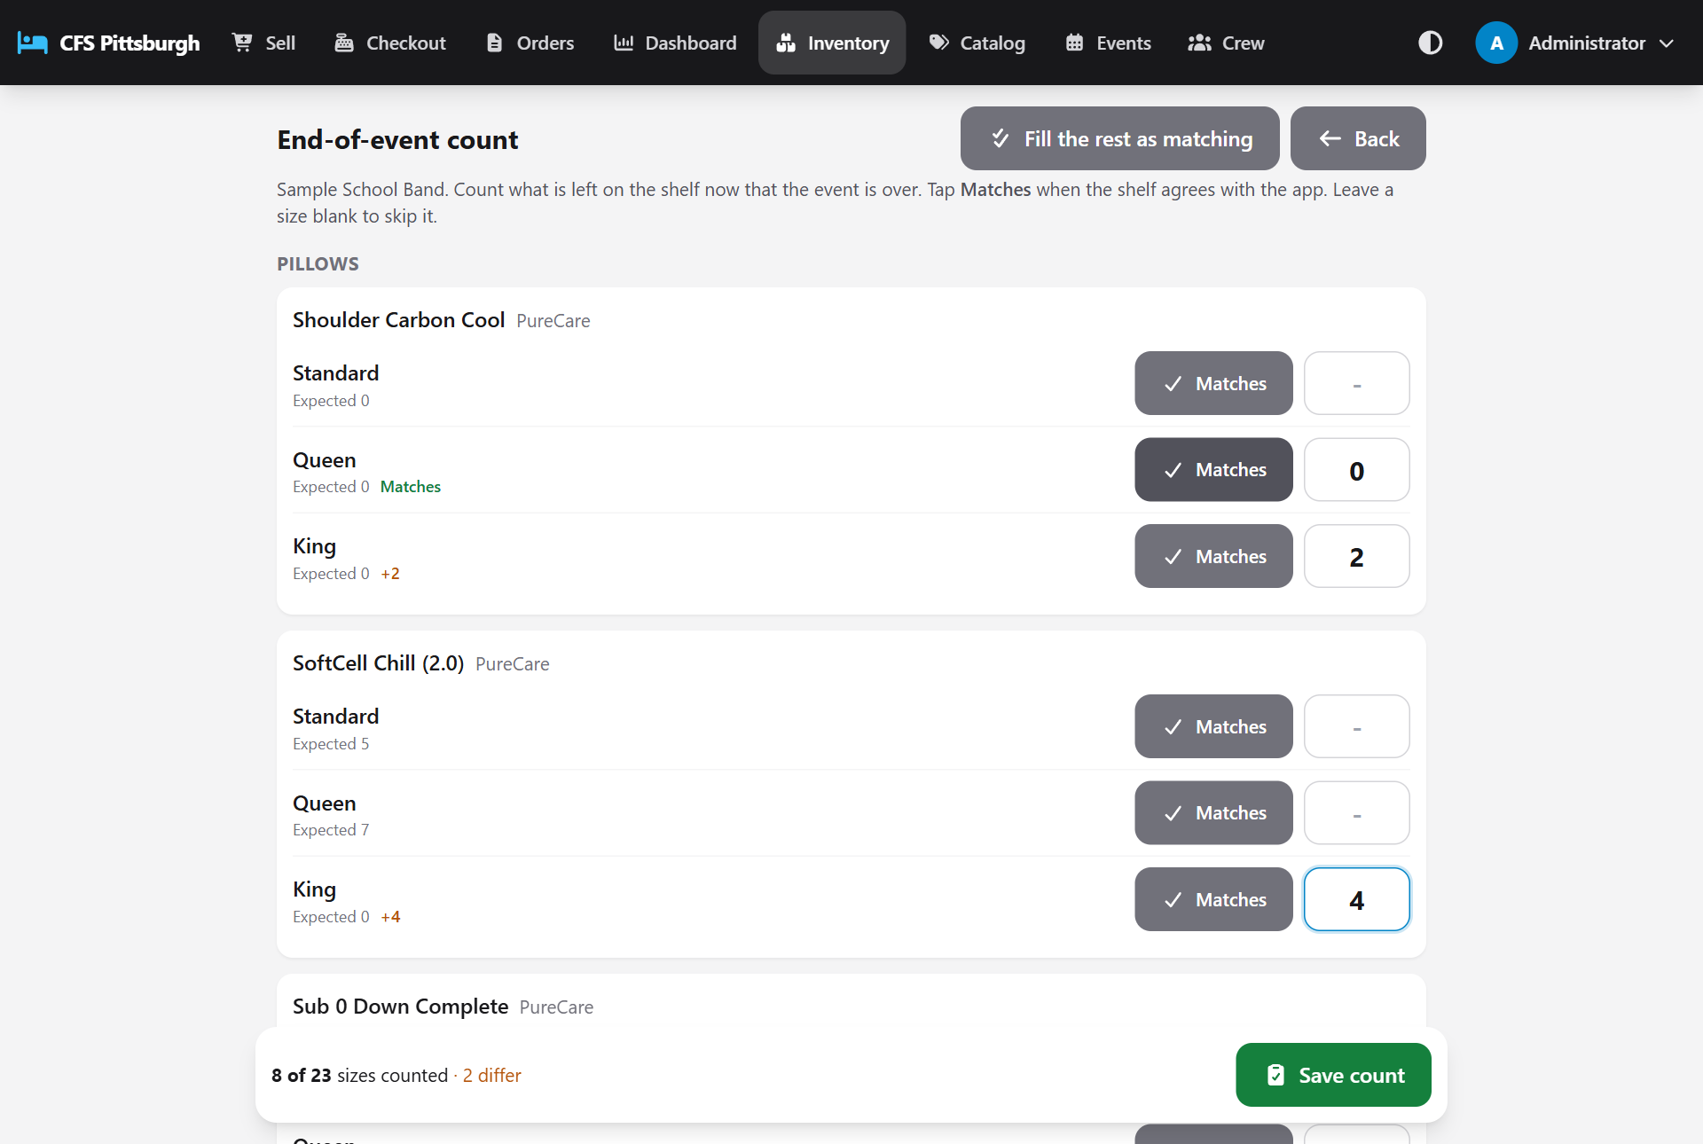
Taking a count
Saving updates each counted size to what's on the shelf and records the count against the event. Both counts print on the event's Accessory Inventory Sheet. To correct a count, tap Recount: it opens with the numbers you entered, ready to change.
Good to know: Counts are saved against the active event, so take the end-of-event count before an administrator switches to the next event.

Admin: setting up an event
Everything in this section is only available to Admins.

Creating or editing an event
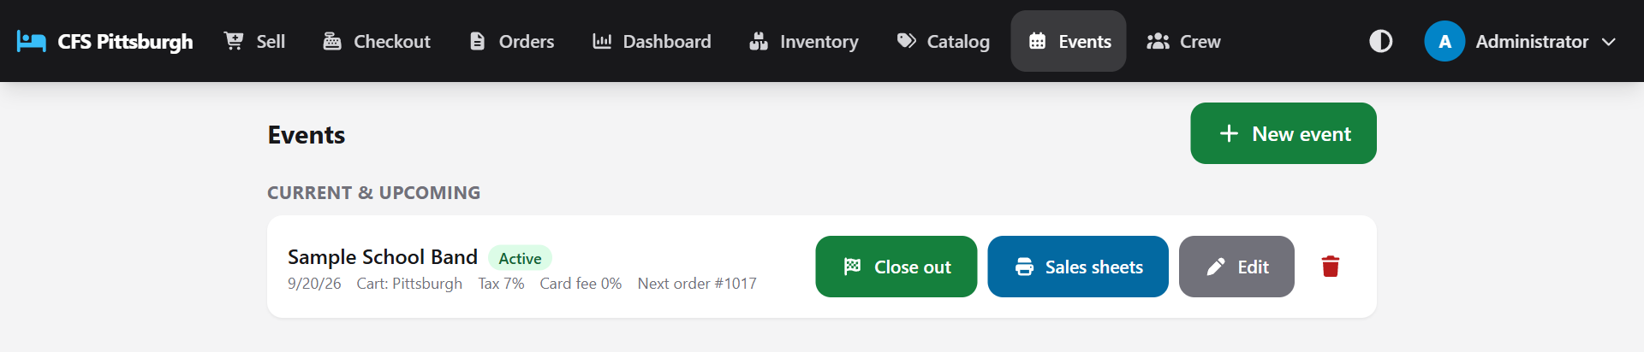
The Events screen
The list is split in two. Current & upcoming at the top holds the active event (always first) and any events still to come, soonest first. Below the Past events line are the events that are over, most recent first. An event counts as past once its date has gone by and it isn't the active event. Small labels mark each one Active, Upcoming or Past.
1. Tap Events, then New event (or Edit on an existing one). A new event starts with the same cart, tax rate and card fee as the most recent one, and its order numbers carry on from the highest used so far.
2. Enter the Organization (for example Hampton Band). This is the name on the sales sheets.
3. Fill in the Cart, Event date, Sales tax % (7 by default) and Card processing fee %.
4. Set the Next order number if you want orders to continue from your paper sheets.
5. Tick Active event so reps can start taking orders, then tap Save.
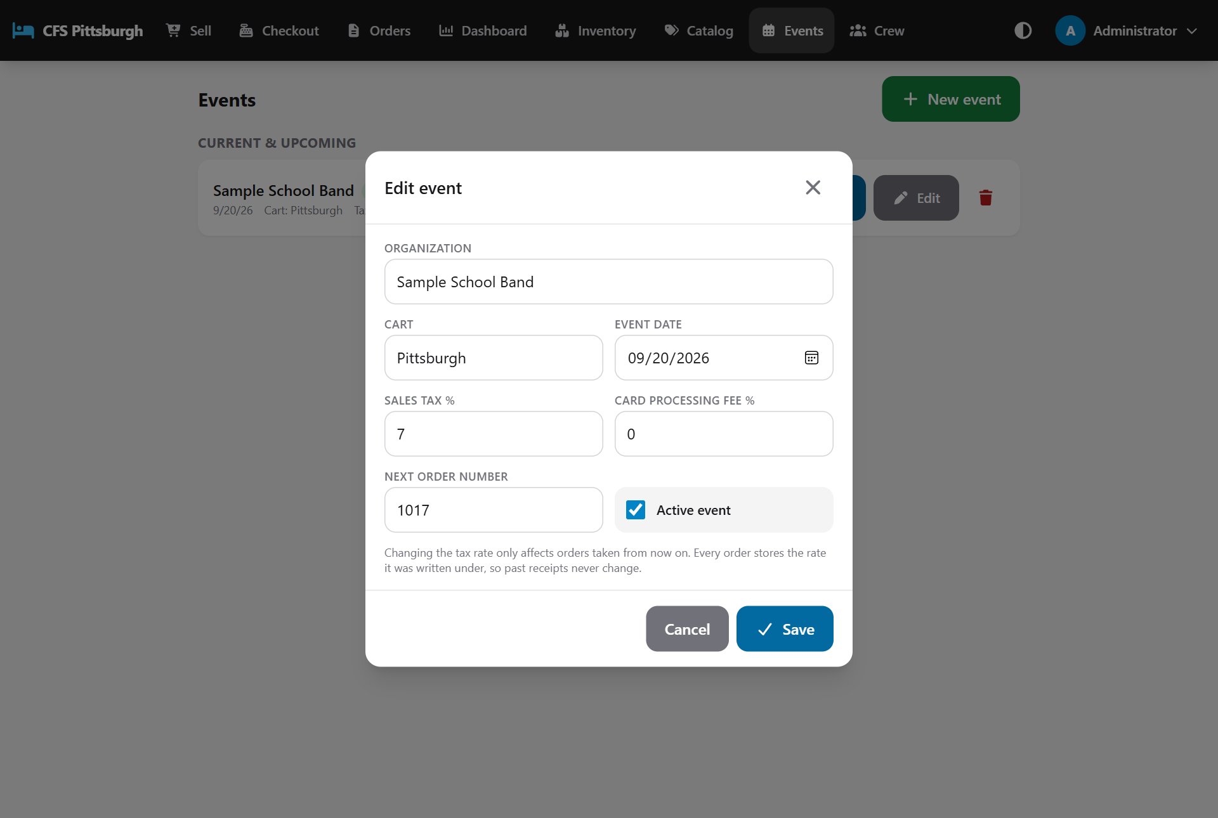
Event settings
Good to know: Only one event can be active at a time. Activating an event switches off the one before it. Changing the tax rate only affects new orders, so past sales sheets never change.

An admin can delete an event only if no orders have been taken for it. An Owner can delete an event along with every order taken at it. See *Owner: permanent deletes*.

Closing out an event
When the event is over, tap Close out on the active event. The close-out page goes through everything worth checking before the cart packs up. Each item shows Done, To do or Check, and you can tap an order to open it:
- Nothing left on the sales floor: orders still being written up.
- Nobody waiting at checkout: orders that were sent over but never paid.
- Balances still owed: completed sales with money still due, which is normal for layaway and financing.
- Start-of-event count and End-of-event count, with a button to take the end count.
- Print the event's sheets: the stat sheet, sales sheets and inventory sheet.
Then tap Close event. It becomes inactive, so no new orders can be taken under it, but its orders, sheets and totals stay available. If anything is still marked To do, the button reads Close anyway and asks you to confirm. An event can be made active again from Events if needed.

Event sales sheets
Tap Sales sheets next to an event (or Print all completed sheets on the Orders screen). The first page is a stat sheet, a one-page summary of the event's unit counts and payment totals. After it comes every completed sales sheet, each on its own page. The last page is the Accessory Inventory Sheet.
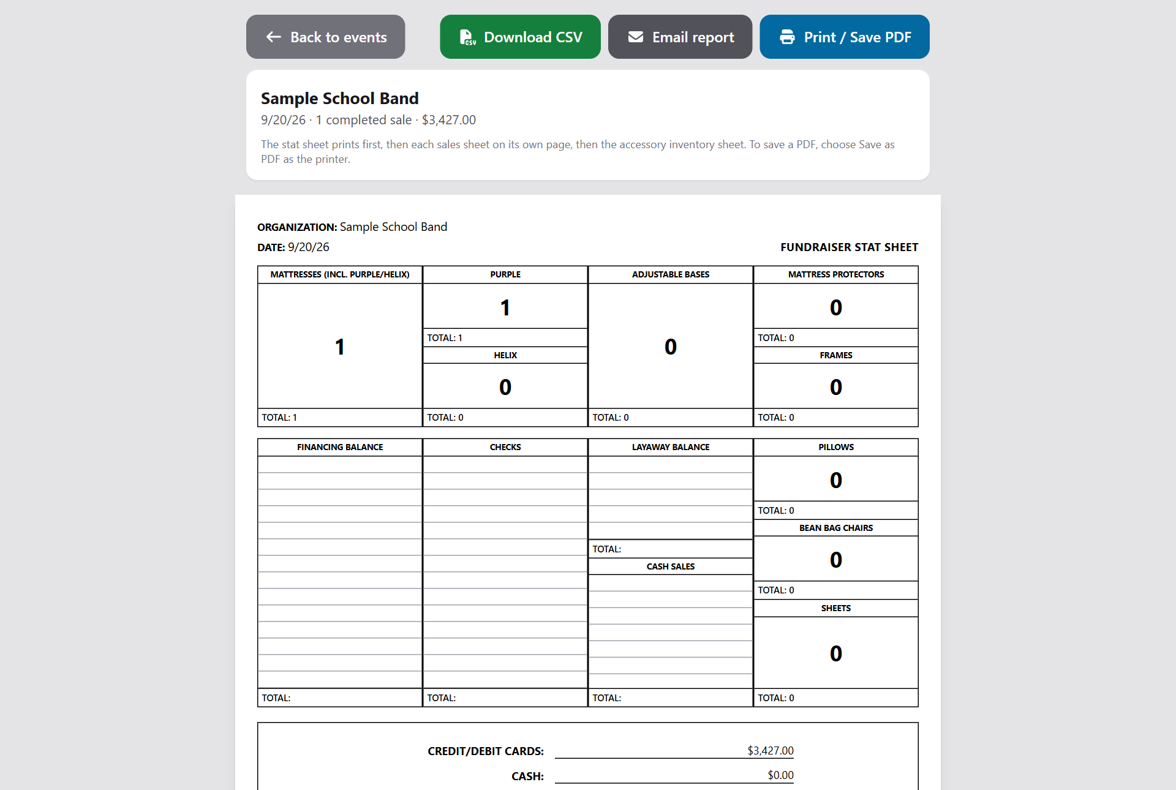
The combined stat sheet and sales sheets for an event

The Accessory Inventory Sheet
This page works like the paper tally sheet. Every counted item is listed by size, with the Start count, how many went home as Take With at this event, how many the app Expected to be left, what the end-of-event count found (Counted) and the Difference. If the count hasn't been done in the app, the Counted column prints blank so the crew can fill it in by hand. The Notes box at the bottom prints the notes saved on the Inventory screen, with lines left for more.
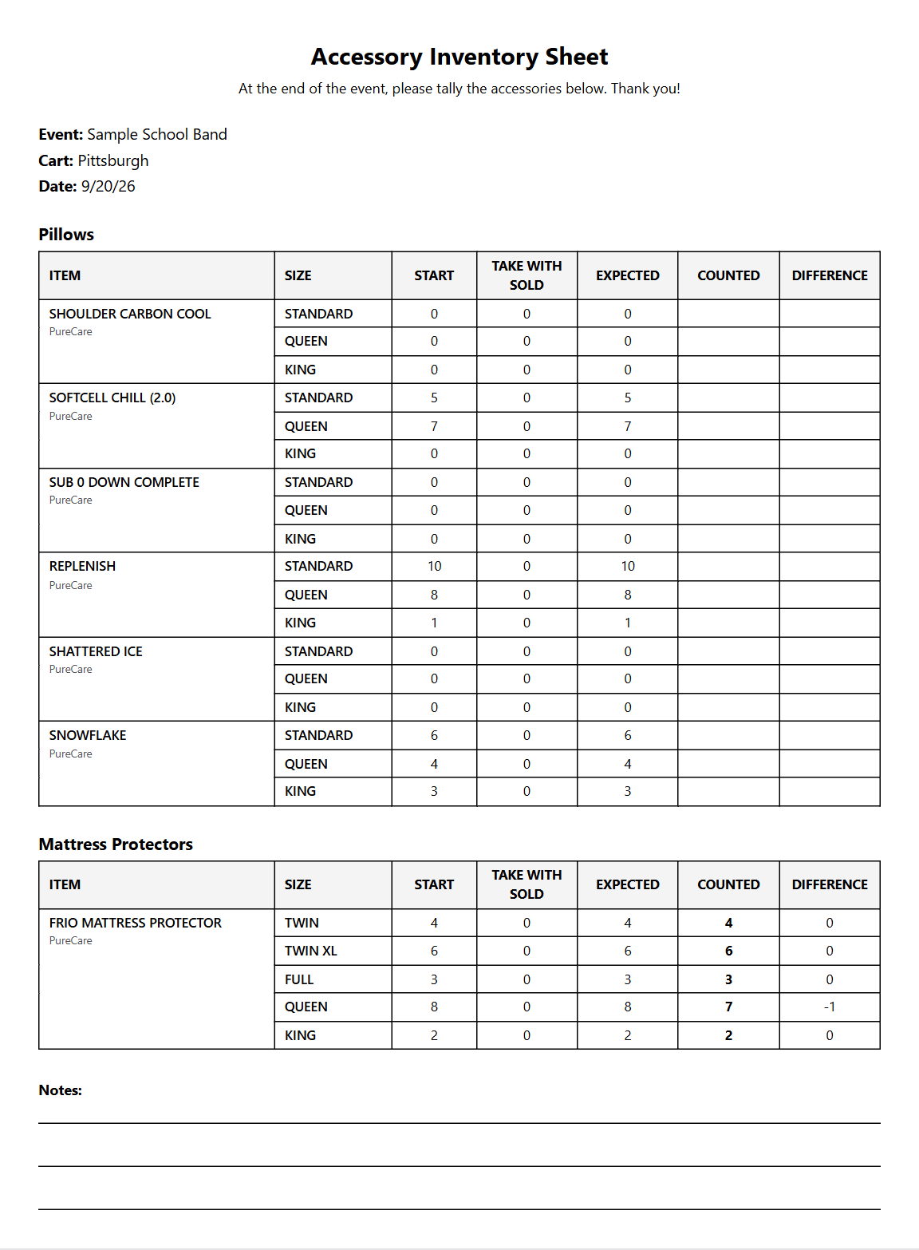
The Accessory Inventory Sheet, printed at the end of the event
- Print / Save PDF: print everything, or choose Save as PDF as the printer to keep a single file.
- Download CSV: a spreadsheet of the sales that opens in Excel.
- Email report: email all of these sheets as one PDF to the director, treasurer or anyone else who needs them (see below).

Emailing the event report
Tap Email report, type one or more email addresses (separate them with commas), add a message if you like, and tap Send.
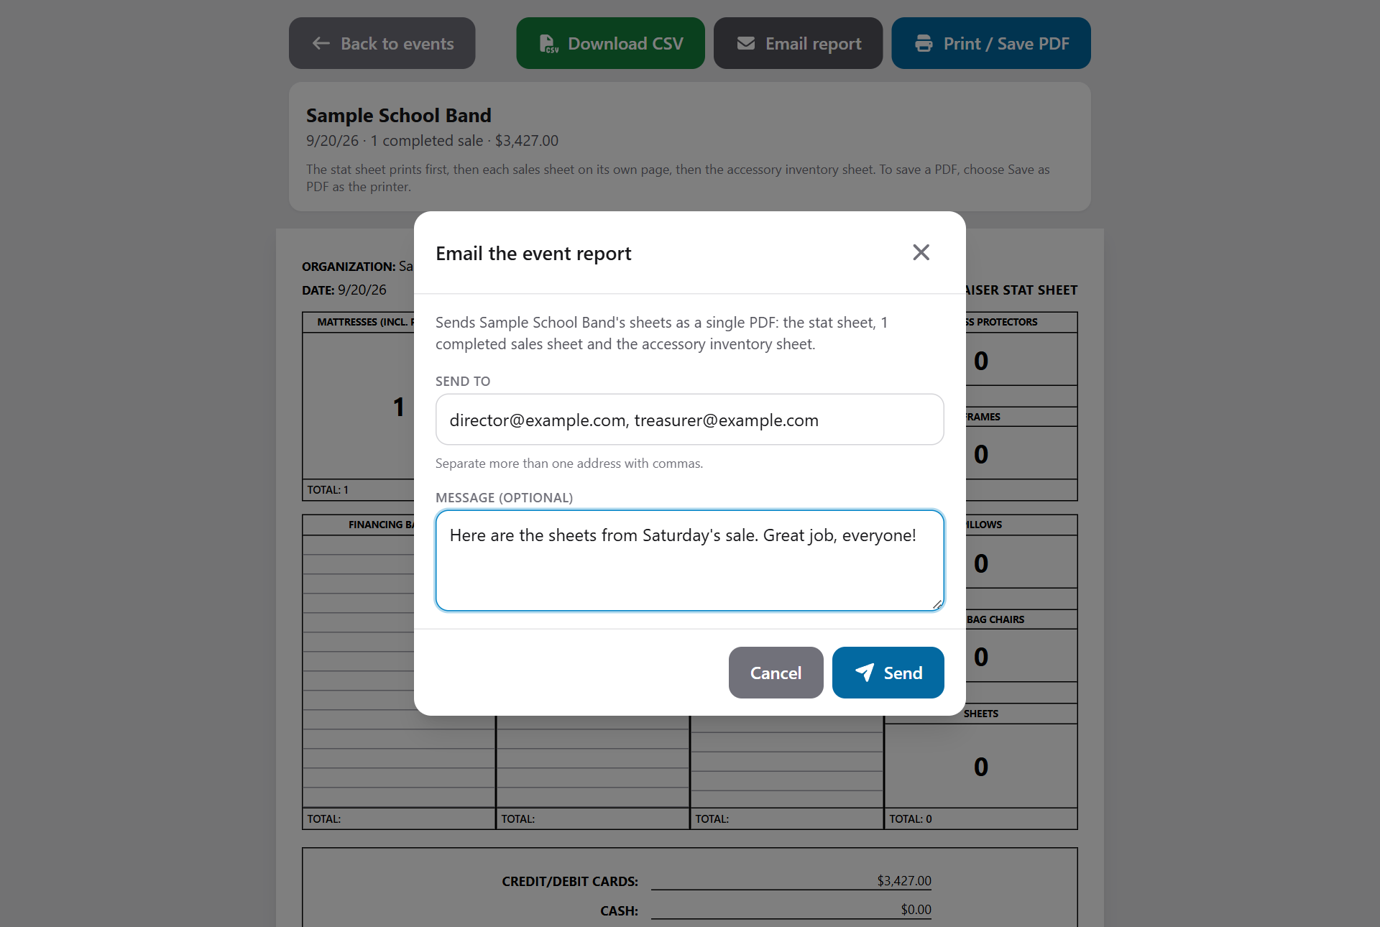
Emailing the event report to the organization
The app puts the same sheets you see on this screen into a single PDF - the stat sheet, every completed sales sheet and the Accessory Inventory Sheet, one per page - and attaches it to the email along with your message.
Good to know: Making the PDF takes a moment for a big event; the app shows which page it's on. Keep the screen open until it says the email was sent. Only completed sales are included, so finish or void any open orders first (see *Closing out an event*).

Admin: managing the catalog
Tap Catalog to manage everything reps can sell. Use the category tabs and Search to find a product.
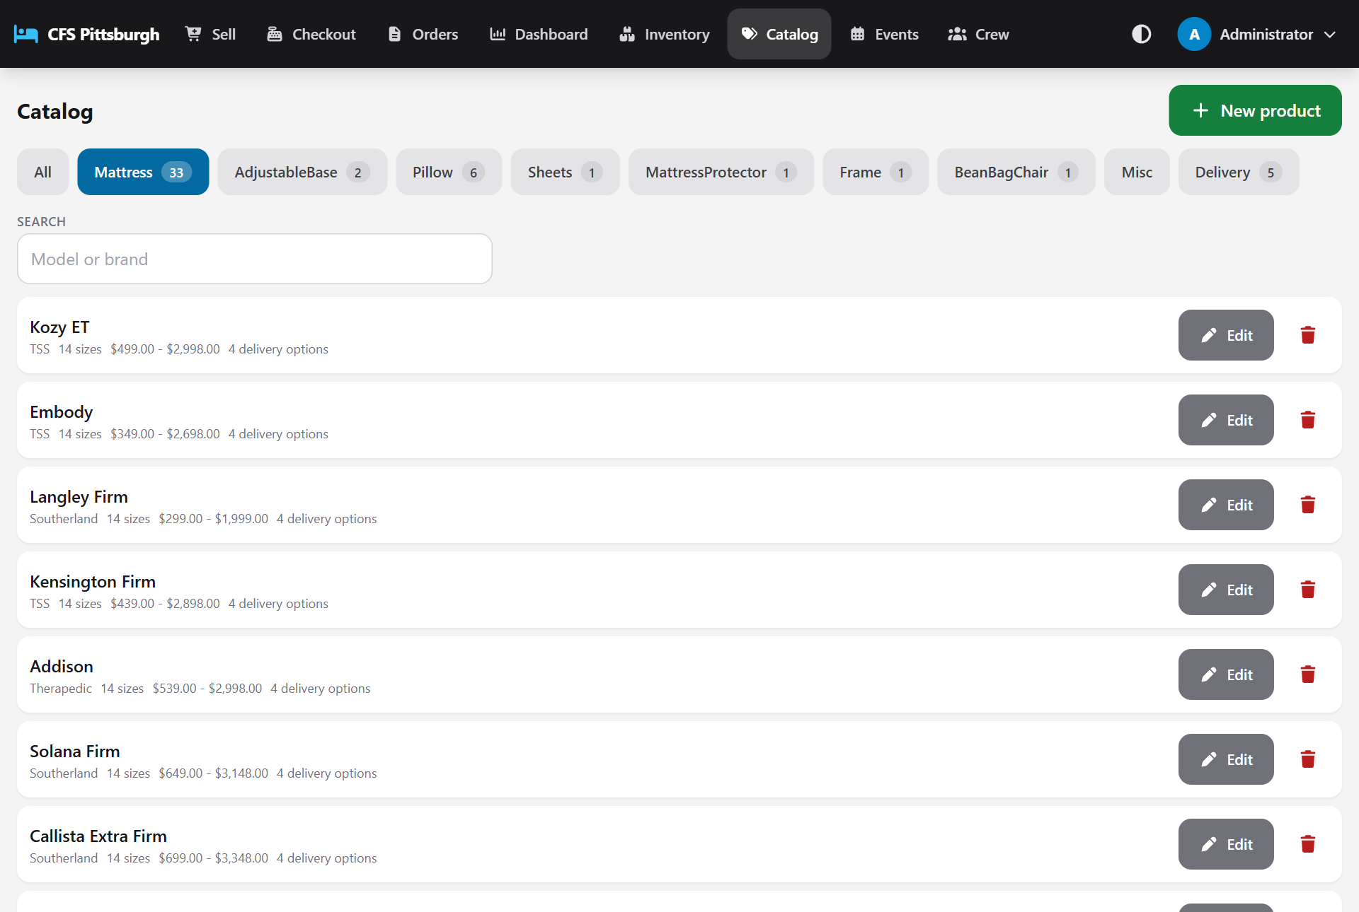
The catalog

Adding or editing a product
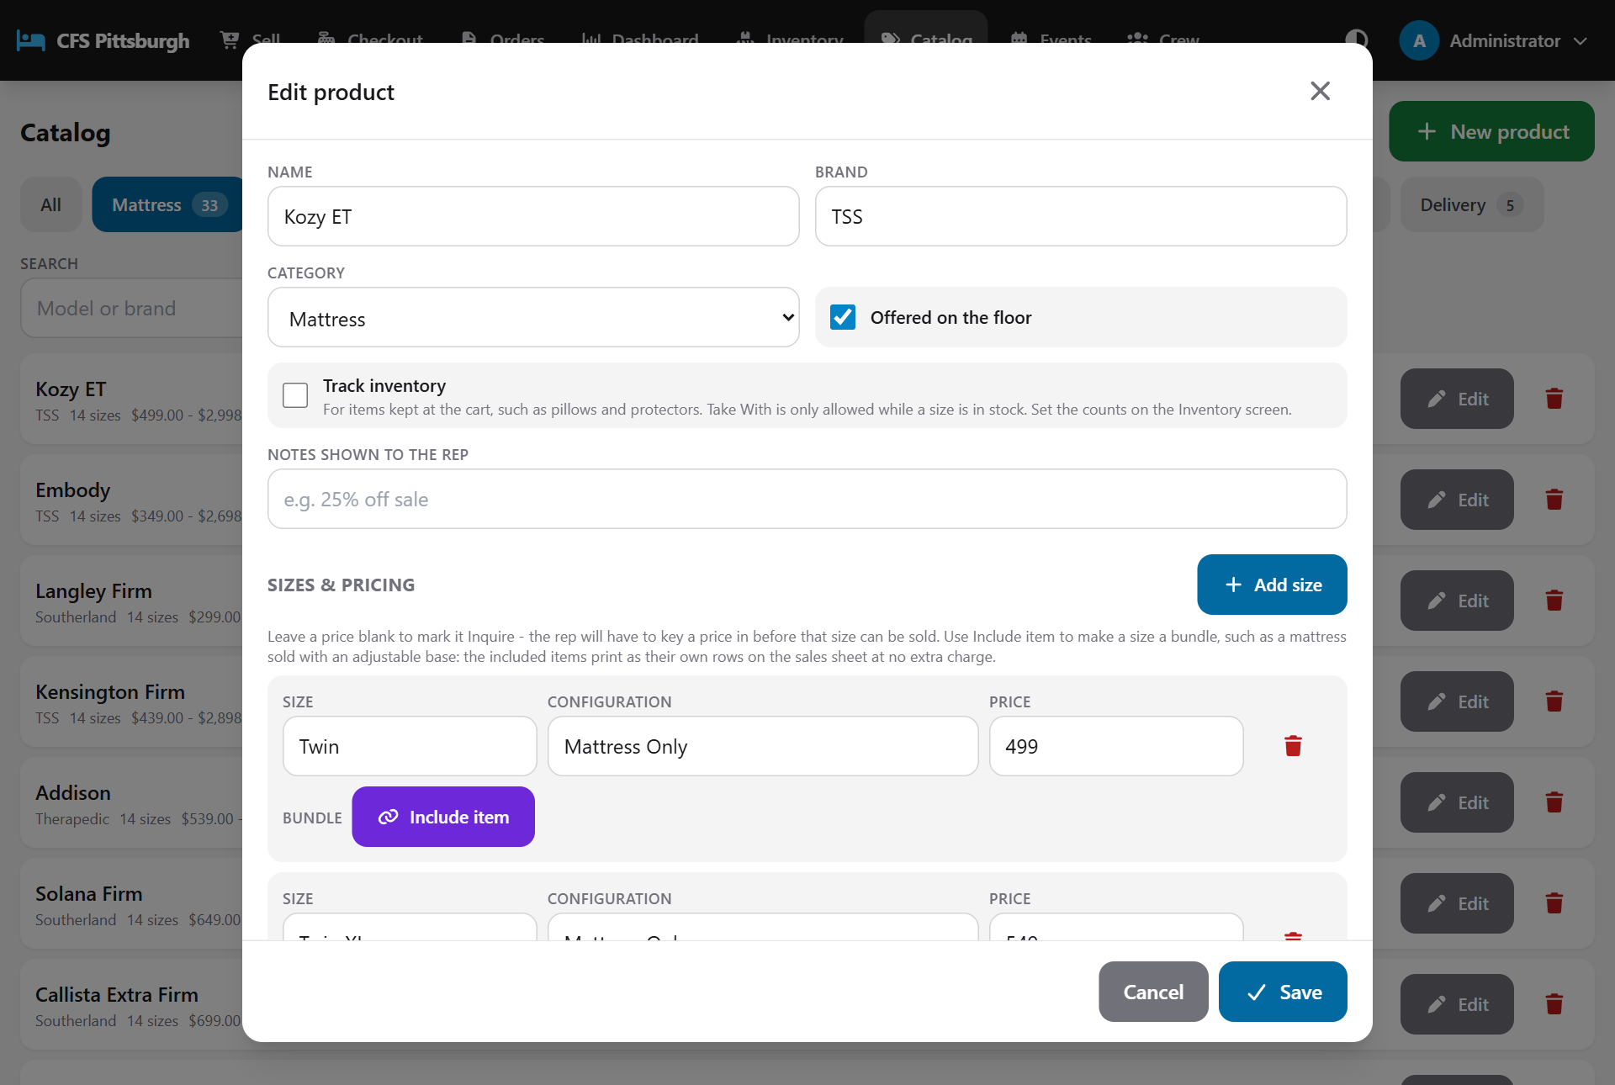
Editing a product's sizes and prices
1. Tap New product, or Edit on an existing product.
2. Enter the Name and Brand, and pick a Category.
3. Optionally add Notes shown to the rep, for example "25% off sale".
4. Under Sizes & pricing, tap Add size for each size. Enter the Size, the Configuration (for example Mattress Only or with an adjustable base) and the Price.
5. Leave a price blank to make it Inquire. The rep will then type in a price at the time of sale.
6. Under Delivery options for this product, tick the shipping and services this product offers. You can type a different price for this product, and choose which one is the Default.
7. Keep Offered on the floor ticked so reps can see the product.
8. Tick Track inventory for items the cart keeps on hand, such as pillows and protectors. Leave it off for anything that always ships, like mattresses. Then tap Save.
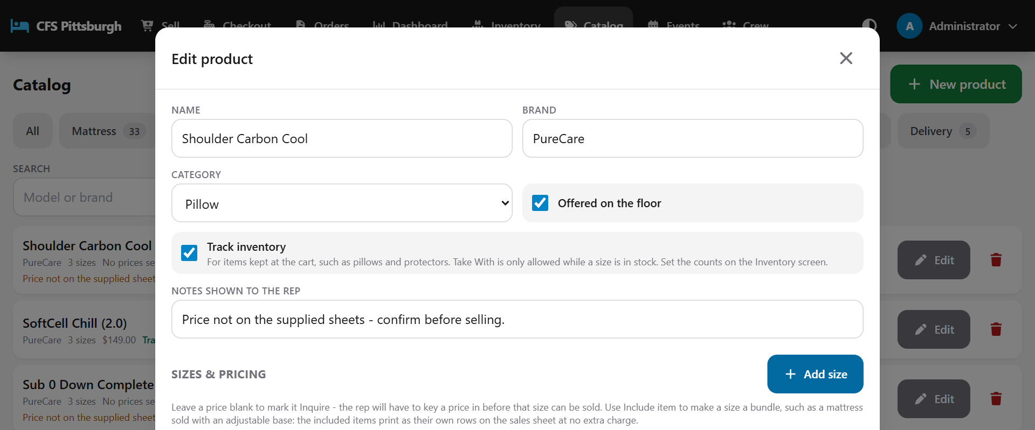
Track inventory switched on for a pillow
Good to know: When you switch on Track inventory, every size starts at 0, so Take With stays off until someone enters the counts on the Inventory screen. Pillows and mattress protectors are tracked from the start.

Building a bundle
To include other items with a size (for example an adjustable base with a mattress set), tap Include item on that size row. Pick the product, its size and the Quantity per bundle. Tick Also include it on every other size to add it to all sizes at once. Included items appear as separate, no-charge lines on the order.

Removing a product
Tap the trash icon. If the product has never been sold, it's deleted. If it has been sold, it's archived instead: it disappears from the sales floor, but old sales sheets still show it correctly. For an Owner, the trash icon always deletes permanently - including a sold product. Past sales sheets still print it exactly as it was sold. Delivery options work the same way.

Delivery and services
Tap the Delivery tab in the Catalog to manage shipping methods and in-home services such as Drop Ship, Take With, White Glove, Haul Away and Local Delivery.
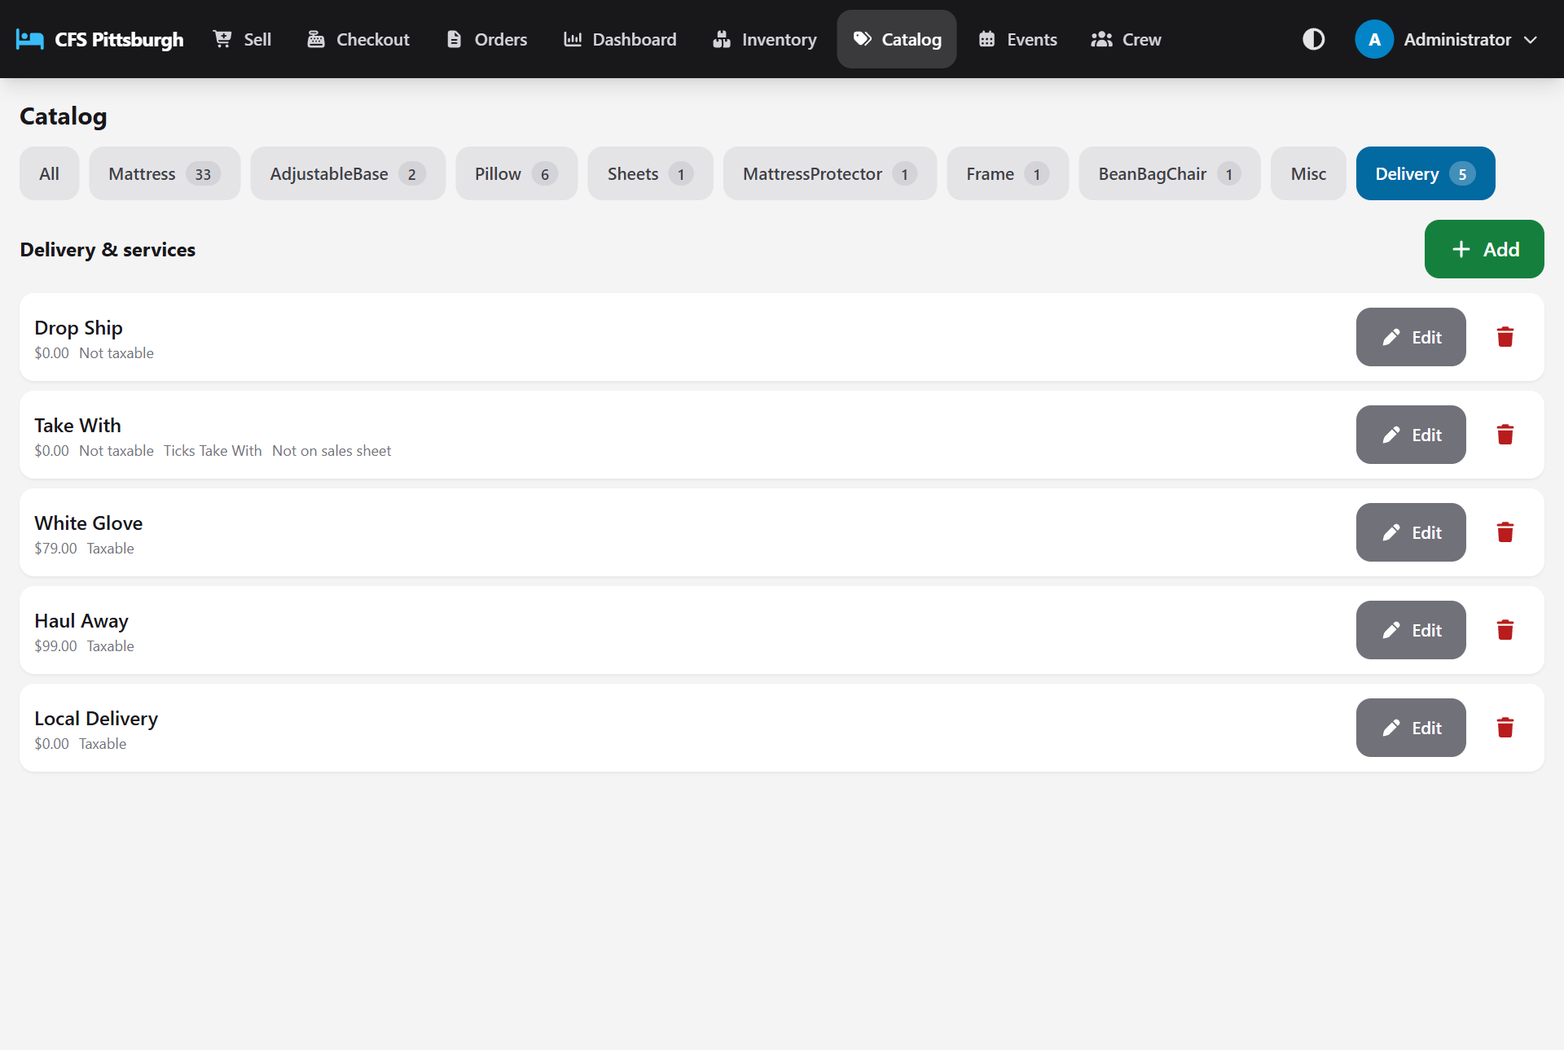
Delivery and service options
Setting | What it does
Name / Price | The label on the sales sheet and the standard charge.
Taxable | Whether sales tax applies to the charge.
Ticks the Take With box | Choosing this option marks the item as taken home today.
Show on sales sheet | Untick this to leave a free row off the printed sheet (Take With is off by default because its column is already ticked). A row with a charge always prints.
Offered on the floor | Untick this to hide the option from reps without deleting it.

Admin: managing the crew
Tap Crew to add accounts and choose what each person can do.
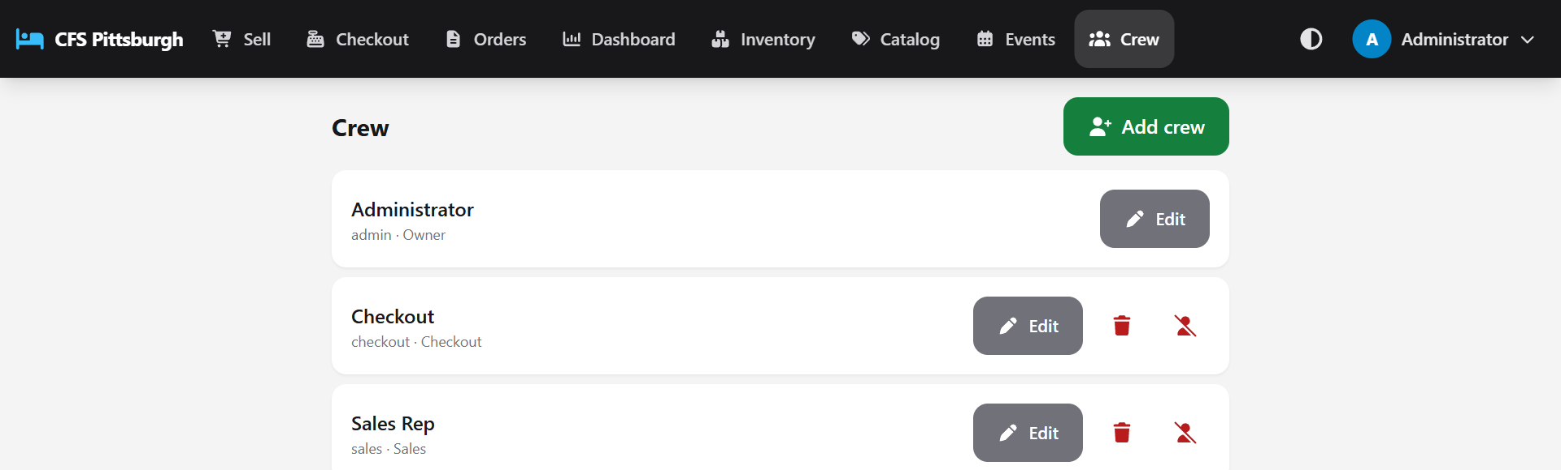
The Crew screen
1. Tap Add crew (or Edit next to a person).
2. Enter their Name, a Username and, optionally, an Email.
3. Set a PIN of 4 to 12 digits. When editing, leave the PIN blank to keep their current one.
4. Choose a Role: Sales, Checkout, Sales & Checkout or Admin (and Owner, if you are one). Nobody can change their own role.
5. Leave Can sign in ticked and tap Save.
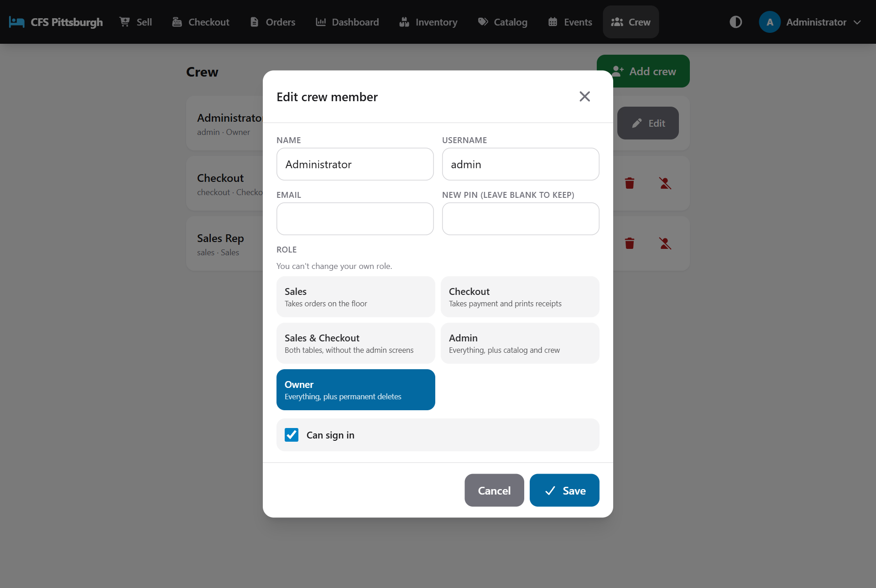
Choosing a role
When someone leaves the team, tap the deactivate icon next to their name. They're signed out and can't sign in again, but all their past sales stay on file, still showing their name.
An administrator can see an owner's account but can't edit or deactivate it. Only another owner can.
An Owner also sees when each person last signed in, under their name (for example *Last login 9/30/26, 9:56 PM (2d 4h ago)*). It's a quick way to spot accounts nobody uses any more, which are worth deactivating. Staying signed in on a tablet doesn't update it - only signing in with a PIN does. Accounts that haven't signed in since this was added show *No sign-in recorded yet*.

Admin: settings
Tap Settings for the things that apply to everyone using the app. On a smaller screen, Settings is under More. The page has three sections, and each one has its own Save button, so changing one never saves half-finished changes in another. Discard changes puts back what was saved, and Reset to default goes back to the app's own values after asking you to confirm.

Business details
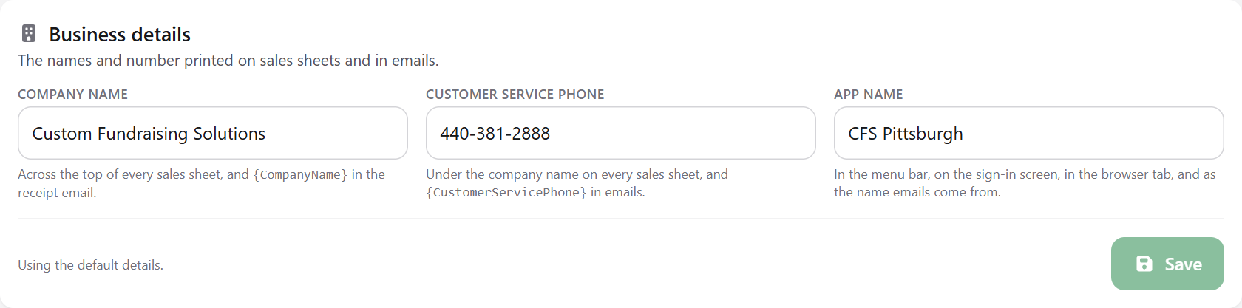
The names and number printed on sheets and emails
Setting | Where it shows
Company name | Across the top of every sales sheet (printed, saved as PDF or emailed), and at the end of the receipt email.
Customer service phone | Under the company name on every sales sheet, and in the receipt email.
App name | In the menu bar, on the sign-in screen, in the browser tab, and as the name emails come from.

Good to know: Changes show straight away for you, and for everyone else the next time their screen loads. Sales sheets already printed or emailed keep the details they had.

Receipt email
This is the note customers get with an emailed receipt. The receipt itself is always attached as a PDF; this is the message around it.
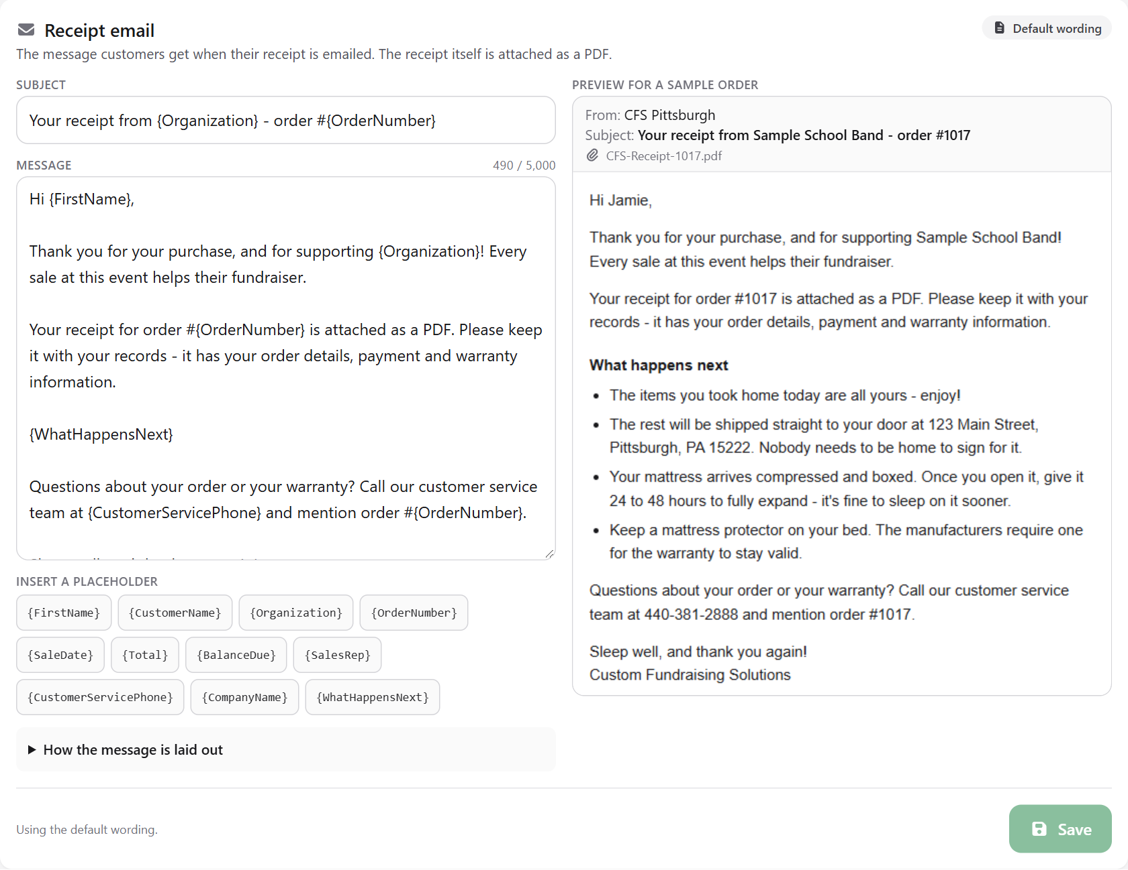
Editing the receipt email, with a live preview on the right
1. Change the Subject or the Message. The preview on the right shows how the email reads for a sample order as you type.
2. In the message, leave a blank line between paragraphs. Start lines with a dash and a space ("- ") to make a bulleted list.
3. To add the customer's name, the order number and so on, tap a placeholder under the message. It goes in where the cursor was - in the subject or the message, whichever you were typing in - and each customer's email fills in their own details.
4. Tap Save. Every receipt emailed from then on uses the new wording.
Placeholder | Becomes
{FirstName} | The customer's first name (or "there", so "Hi {FirstName}," still reads well without a name)
{CustomerName} | The customer's full name
{Organization} | The organization the fundraiser is for
{OrderNumber} | The order number
{SaleDate} | The date of the sale
{Total} | The order total
{BalanceDue} | What is still owed
{SalesRep} | The sales rep's name
{CustomerServicePhone} | The customer service number from Business details
{CompanyName} | The company name from Business details
{WhatHappensNext} | A "What happens next" list written for that order: what went home today, what's being shipped and where, the boxed mattress, keeping a protector on, and any balance owed. Put it on a line of its own; it disappears when none of it applies.

Tip: If a placeholder is misspelt, the screen points it out in orange and it would be sent exactly as typed. Check it against the list.

Dashboard
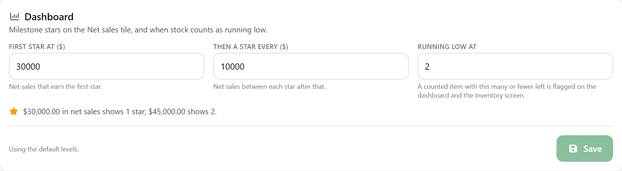
When stars are earned, and when stock is running low
Setting | What it does
First star at | The net sales that earn the first gold star on the dashboard's Net sales tile (normally $30,000).
Then a star every | The net sales between each star after that (normally $10,000). The line under the boxes works an example out for you.
Running low at | A counted item with this many or fewer left shows Running low on the Inventory screen and in Stock to watch on the dashboard (normally 2).

Owner: permanent deletes
Everything in this section is only available to Owners. Admins can archive, deactivate and void, which keeps the records on file. An owner can remove records from the database for good. There's no undo, so every permanent delete asks you to type DELETE before the button unlocks.
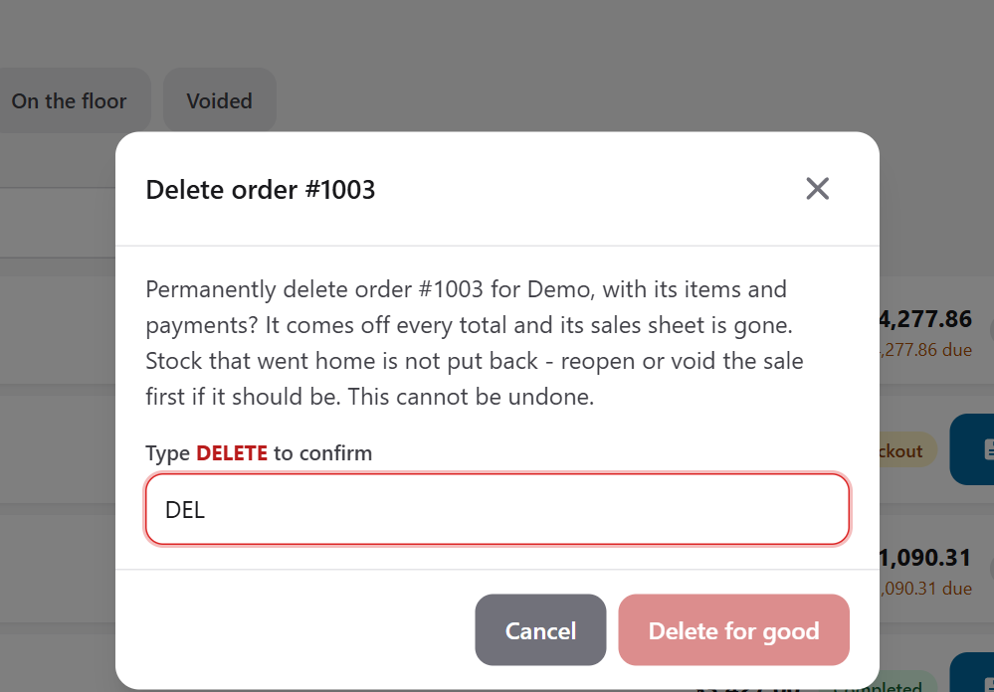
A permanent delete has to be typed out
Delete | Where | What happens
A crew account | Crew: the red trash icon | The account is removed. Their sales stay on file, but their name is cleared from them: the CFS Rep Name and checkout name on those sales sheets print blank, and their inventory changes no longer say who made them. To keep their name on past sales, deactivate them instead.
An order | Orders: the red trash icon | The order, its items and its payments are removed, and it comes off every total. Stock that went home is not put back. If it should be, reopen or void the sale first.
An event | Events: the trash icon | The event and every order taken at it are removed. Inventory counts are kept.
A product | Catalog: the trash icon | Removed from the catalog, from any bundle that included it, and from the inventory. Past sales sheets still print the item as sold.
A delivery option | Catalog, Delivery tab: the trash icon | Removed, and products stop offering it. Past sales sheets still print the shipping row.

Important: You can't delete your own account or change your own role, so there is always at least one owner. If a database ever ends up with no owner, the longest-standing administrator is made the owner automatically the next time the app starts.

Tips and troubleshooting
If the tablet loses touch with the server (usually the Wi-Fi dropping out), an amber strip appears under the menu: Can't reach the server - retrying. Anything you change while it's showing won't save. You can still move between screens, and the strip disappears on its own, with a Reconnected message, once the server answers again.

I can't start a new order.
No event is active. An administrator needs to open Events, edit the fundraiser and tick Active event.

The Complete button is greyed out.
The order needs at least one item and the customer's name.

The card fee showed up on the total.
That's expected when Credit/Debit Card is selected. Switch to Cash or Check and it comes off.

A product shows "Inquire" instead of a price.
Type in the agreed price in the Price box that appears when you pick that size.

The Take With button is greyed out.
That size is out of stock, or there aren't enough for the quantity you picked. Choose a shipping method instead, or lower the quantity. If there really are some on the shelf, ask checkout to update the count on the Inventory screen.

Checkout says an item is out of stock and won't complete the order.
Someone else took the last one first. Remove the item's Take With row, add a shipping method with Add service, and complete the order again.

Email says email isn't set up.
The app hasn't been connected to an email account yet. Print the receipt or report instead, and ask whoever looks after the app to add the email settings.

I want to change what the receipt email says.
An administrator can change it under Settings (see *Admin: settings*).

The customer didn't get their receipt email.
Ask them to check their junk or spam folder. Open the sales sheet, tap Email, check the address carefully and send it again.

Complete sale is greyed out.
The customer still needs to confirm their details, initial each point and sign. Tap Hand to customer in Acknowledgements. If their details were changed after they confirmed them, they need to confirm them again.

The inventory count looks wrong.
Tap the clock icon to see its history, then tap the number and enter the real count. Add a note so everyone knows why it changed.

I can't find a product.
Check that you're on the right category tab or All, and clear the search box. If it still isn't there, an admin may have hidden it. Use Something not in the catalog in the meantime.

The customer changed their mind at checkout.
Use Send back to return the order to the sales floor, or edit the items right there at checkout.

I want a different PIN.
Tap your initials in the top-right corner, then Change PIN. If you've forgotten your current PIN, an administrator can set a new one on the Crew screen.

A completed order has a mistake.
Ask an admin to Reopen it from the Orders screen.

I can't see a screen mentioned in this guide.
Your role doesn't include it. Ask an administrator if you need access.

A new order isn't showing at checkout.
Tap the order list or refresh the page. Orders normally appear straight away.

I'm on a shared tablet.
Always check the name in the top-right corner before you start, and sign out when you're done.

Quick reference

Sales rep checklist
1. New: start the order.
2. Add item: pick the product, size, shipping and quantity.
3. Fill in the customer details, or tap Hand tablet to customer.
4. Tap Complete and send the customer to checkout.

Checkout checklist
1. Tap the customer's order in Waiting to pay.
2. Review the items and details with the customer.
3. Pick the payment method, then Record payment.
4. Hand to customer to confirm details, initial and sign.
5. Complete sale, then Print the sales sheet or Email it to the customer.

Inventory counts
1. Before the doors open: Inventory → Start-of-event count → Count now.
2. After the event: Inventory → End-of-event count → Count now.
3. Enter what's on the shelf for each size, or tap Matches (or Fill the rest as matching), then Save count.
4. An admin prints the event's sheets. The last page is the Accessory Inventory Sheet.

Order status at a glance
Status | Meaning
On the floor | Still being written up by a rep.
At checkout | Waiting for payment.
Completed | Paid and signed. Counts in the totals.
Voided | Cancelled. Kept for the records only.

